
System Requirements Specification

Venture

CTS Confidential Materials for Purposes of Training Only

ABC Bank

Table of Contents

1.0 Introduction 4
2.0 Scope of this System Requirements Specification Document 5
3.0 System Overview 6
4.0 Assumptions 7
5.0 Infrastructure Requirements 8
6.0 Functional Requirements 8
7.0 Data Requirements 61
8.0 Quality Requirements 63
9.0 Report Requirements 65
10.0 Report Model Requirements 72
11.0 Data Conversion Requirements 77
12.0 Performance Requirements 79
13.0 Delivery Requirements 79
14.0 Documentation Requirements 79
15.0 Training Requirements 79
16.0 Client Requirements 79
17.0 Formal Change Process 80
Appendix A - Screen Shots 81
Appendix B - Report Layouts 91
Appendix C - Data Dictionary 94
Appendix D - Request for Change 98
Appendix E - Future Versions Enhancements List 100

Revision History

Version | Author(s) | Description | Date
1.0 | Matt Jones | Initial draft | 7/9/2009
1.1 | Matt Jones | Revised with Feedback | 7/21/2009
1.2 | Matt Jones | Revised with Feedback | 7/23/2009

- Introduction

This document covers software functional requirements for the Venture engagement.

TBD (To Be Determined) indicates specific information that is unknown at this time. TBR (To Be Resolved) indicates general processes and procedures that are unknown at this time. The team prioritizes each TBD and TBR based on the following:

TBD1, TBR1 – The team will list questions for which it needs immediate responses as TBD1 or TBR1. The client must answer these questions before further engagement activities can resume.

TBD2, TBR2 – Questions concerning issues listed as TBD2 or TBR2 are less vital than those above and the team will require a response within a few days. The client must provide answers before the team can complete detailed design.

TBD3, TBR3 – Client must answer questions concerning issues listed at TBD3 or TBR3 within a time frame as specified in meetings or correspondence. The client must answer these issues before CTS can complete implementation.

- Scope of this System Requirements Specification Document

The following diagram defines the use cases that identify the scope of the system. This diagram represents a general overview of the system.

Figure 1

The following table describes the significance of the color-coding in Figure 1.

Color | Significance
Blue Actors (Stick Figures) | The Blue Actors represent the human users of the solution.
Green Actors | The Green Actors represent the software or software for which the solution interacts.
Tan Actors | The Tan Actors represent the human administrative users of the solution.
Blue Use Cases (Ovals) | The Blue Use Cases represent top-level functions of the solution.
Light Blue Use Cases | The Light Blue Use Cases represent child functions of top-level functions.
Green Use Cases | The Green uses cases represent reporting functions of the solution.
Tan Use Cases | The Tan uses cases represent administrative functions of the solution.

- System Overview

ABC Bank Technology currently utilizes Clarity and Microsoft Office documents to manage IT Projects. ABC Bank Technology is looking to implement an ASP.Net solution to replace Clarity.

CTS is a regional IT professional services firm that specializes in custom software development, Microsoft Office SharePoint Server (MOSS), business intelligence, and quality assurance activities. ABC Bank asked CTS to provide assistance with the implementation of the project management solution. The preliminary name for the solution is Venture.

  - System Architecture

The Venture application will be an n-tier ASP.Net application hosted on the ABC Bank intranet. It will consist of a web component and Microsoft SQL Server 2008 database. The application will access the Venture database. The solution will contain a hyperlink to a document library for each project. The following diagram is a basic representation of the physical system architecture:

- Assumptions

CTS makes the following assumptions with regards this engagement.
  - System

CTS makes the following assumptions about the requirements for the Venture Solution:

- The Venture Solution will only be accessible within the ABC Bank firewall.
- The email integration provided by the Venture solution will be based on the user of MailTo HTTP tag.

  - Developer Partnership

CTS makes the following assumptions about the requirements for the Venture Solution:

- ABC Bank will provide adequate access to all systems required for system implementation.
- If needed, ABC Bank will provide access to all pertinent systems after normal business hours, with prior approval.
- ABC Bank will provide access to key advisors in a timely fashion.
- ABC Bank will make hardware available during development to facilitate integration testing.
- ABC Bank will provide the application hardware infrastructure during the implementation phase so that load testing, configuration, and performance can be closely monitored through the development process, instead of at the time of deployment.

- Infrastructure Requirements

The following sections describe the hardware and software requirements for the solution.

  - Hardware

    - Web Server

- The solution will reside on existing ABC Bank ASP.Net servers.

    - Database Server

- The solution will reside on existing ABC Bank SQL Server cluster.

  - Software

    - Web Servers

- Microsoft Windows Server 2003 SP 2 or higher
- Microsoft Internet Information Services v6.0 or higher
- Microsoft .NET Framework v3.5 SP 1

    - Database

- Microsoft SQL Server 2008 SP 1
- Microsoft SQL Server Report Builder 2.0

- Functional Requirements

The following sections describe the functional requirements for the Venture Solution. All of the sections below except section 6.1 General Requirements map directly to the use case model identified in Section 2 Figure 1.

  - General Requirements

The following table identifies general requirements for the Venture solution.

ID | Category | Requirement
 | Toggle Insert Buttons | Many of interface prototypes contact Insert buttons for inserting into the grids. If a user has selected a record for editing, the text of the Insert button will be change to Update.
 | Formats | CTS will prefix all negative numbers with a minus sign.
 | Formats | The solution will display all dates in the MM/DD/YYYY format.
 | Formats | The solution will display currency values in the $#,###.## format.
 | Grid Spans | The grids in the solution will show a maximum of 25 records. The user will have to hit a scroll bar to see additional records.

  - View Today

    - Overview

The View Today process launches the Today page of the Venture solution. The Today page is the default page of the Venture solution. Venture users will utilize this page to see the key information about the projects for which they are on the project team. The data dictionary describes the key information.

    - Activities that Triggers Process

The user initiates this process by either launching the Venture solution or clicking on the Today menu item.

    - Process Results

This process does not have a direct result. The processes spawned by this process cause results

    - Actors Involved

The following list identifies the actors that interact with the View Today screen:

- User
- Administrator

    - Storyboard

The following diagram illustrates the Today Page that the solution will utilize to support the View Today Process.

- If the user clicks the Project hyperlink, the application will transfer the user to the Details tab of the Project Maintenance screen. The solution will retrieve the selected project.
- If the user clicks the Project hyperlink, the application will transfer the user to the Milestones tab of the Project Maintenance screen. The solution will retrieve the selected project.
- If the user clicks the Project Number hyperlink, the application will transfer the user to the Details tab of the Project Maintenance screen. The solution will retrieve the selected project.
- If the user clicks the Search button, the solution will populate the My Projects grid with projects matching the specified parameters. The Search Projects workflow below describes the transition.

    - Workflow Models

      - Search Projects

The following diagram illustrates Search Projects workflow.

    - Error Messages

Message in workflow | Error Message
Search Parameter | “Please enter at least one search parameter.”
No Results Found | “Your search did not return any records. Please refine your search.”
Maximum Results | “Your search returned more than 25 records. Please refine your search.”

    - Data Dictionary

The following table describes the attributes related to the View Today Process.

Attribute | Data Type | Format | Details | Max Length
Project Tracking Items
Project  (Project.ProjectName) | String | Hyperlink | - See Project Tracking Items Business Rule  - This is a view-only field. | 50
ID #  (Issue.IssueNumber) | Integer |  | - This is a view-only field.
Type  (IssueType.IssueType) | String |  | - This is a view-only field. | 15
Issue  (Issue.Issue) | String |  | - This is a view-only field. | 255
Assigned To  (Resource.Resource) | String |  | - This is a view-only field. | 50
Next Action  (Issue.NextAction) | String |  | - This is a view-only field. | 255
Target Date  (Issue.TargetDate) | DateTime |  | - This is a view-only field.
Status  (IssueStatus.IssueStatus) | String |  | - This is a view-only field. | 15
Upcoming Milestones
Project  (Project.ProjectName) | String | Hyperlink | - See Upcoming Milestones Business Rule  - This is a view-only field. | 50
Milestone  (StandardMilestone.StandardMilestone)  (ProjectMilestone.Milestone) | String |  | - This is a view-only field. | 50
Baseline Start  (ProjectStandardMilestone.BaselineStart)  (ProjectMilestone.BaselineStart) | DateTime |  | - This is a view-only field.
Baseline Finish  (ProjectStandardMilestone.BaselineFinish)  (ProjectMilestone.BaselineFinish) | DateTime |  | - This is a view-only field.
Actual Start  (ProjectStandardMilestone.ActualStart)  (ProjectMilestone.ActualStart) | DateTime |  | - This is a view-only field.
Actual Finish  (ProjectStandardMilestone.ActualFinish)  (ProjectMilestone.ActualFinish) | DateTime |  | - This is a view-only field.
% Complete  (ProjectStandardMilestone.PercentComplete)  (ProjectMilestone.PercentComplete) | Decimal |  | - This is a view-only field.
My Projects
Project Number  (Project.ProjectYear)  (Project.ProjectSeqNumber) | String | Hyperlink | - See Format Project Number Business Rule.  - See My Projects Business Rule.  - This is a view-only field.
Project Name  (Project.ProjectName) | String |  | - This is a view-only field. | 50
Status Update |  |  | - See Status Update Flags Business Rule.  - This is a view-only field.
My Projects Search |  |  | - The maximum number of search results is 25
Project Name | String |  | - Search will look for any instance of the specified characters within the Project Name | 50
Project Number | String | YYYY-1 | - Search will look for any instance of the specified characters within the Project Number | 10

    - Business Rules

Business Rule | Description
Format Project Number | Project Number is a combination of ProjectYear and ProjectSeqNumber. The formula for Project Number is Project Year & “ – “ & ProjectSeqNumber.
Status Update Flags | The Status Update field will show a colored flag illustrating the time since the last status update. The following table describes the colors.
  Color | Time Since Last Status Update
  Green | Within 7 Days
  Yellow | 8 to 14 Day
  Red | More than 14 Days
Project Tracking Items | The Today page will show any open Project Tracking Items where the current user is on the Project Team and the Tracking Item is past due or coming due within the next 7 days. This grid will have sortable columns.
Upcoming Milestones | The Today page will show any Standard or Project Specific Milestone where the current user is on the Project Team and the Milestone is incomplete and due within the next 14 days. Additionally, the solution will display past due milestones.
My Projects | The Today page will show all open projects where the current user is on the Project Team.

  - Maintain Project Details

    - Overview

The Maintain Project Details process launches the Details tab of the Project Maintenance page within the Venture solution. Venture users will utilize this page to enter/update the initial Project information. The data dictionary describes the information the user will maintain.

    - Activities that Triggers Process

The user initiates this process by either selecting a project on the Today page or clicking the New button.

    - Process Results

The result of this process is that the solution has saved project information to the SQL Database.

    - Actors Involved

The following list identifies the actors that interact with the Maintain Project Details screen:

- User
- Administrator

    - Storyboard

The following diagram illustrates the Details Tab of Project Maintenance Page that the solution will utilize to support the Maintain Project Details Process.

- If the user clicks the New button, the solution will generate a new project. The New Project workflow below describes the transition.  - If the user clicks the Save button, the solution will generate a new project. The Save Project workflow below describes the transition. | 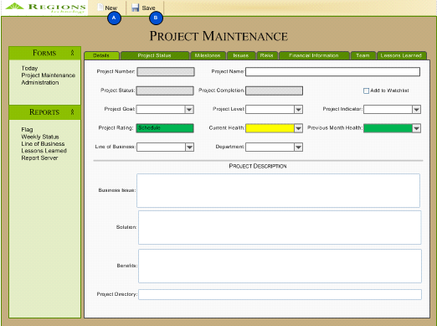

    - Workflow Models

      - New Project

The following diagram illustrates New Project workflow.

      - Save Project

The following diagram illustrates Save Project workflow.

    - Error Messages

Message in workflow | Error Message
Missing Value | “Please [Select/Enter] a [Specific Field].”
Error | “The following error has occurred. [Error Number] – [Error Description]. Please contact your System Administrator.“

    - Data Dictionary

The following table describes the attributes related to the Maintain Project Details Process.

Attribute | Data Type | Format | Details | Max Length
Project Number  (Project.ProjectYear)  (Project.ProjectSeqNumber) | Integer |  | - This is a view-only field.  - See 6.3.7 Format Project Number Business Rule.  - See New Project Number Business Rule
Project Name  (Project.ProjectName) | String |  | - This field is required. | 50
Project Status  (Status.Status) | String |  | - This field is required.  - See Calculate Project Status Business Rule. | 25
Project Completion | Calculated |  | - This is a view-only field.  - See Calculate Project Completion Business Rule.
Add to Watchlist  (Project.Watchlist) | Boolean |  | - This field is required.  - The field will default to false.
Project Goal  (ProjectGoal.ProjectGoal) | String |  | - This field is required.  - See List of Project Goals Business Rule. | 50
Project Level  (ProjectLevel.ProjectLevel) | String |  | - This field is required.  - See List of Project Levels Business Rule. | 50
Project Indicator  (Indicator.ProjectIndicator) | String |  | - This field is required. | 50
Project Rating | Calculated |  | - This is a view-only field.  - See Calculate Project Rating Color Business Rule.  - See Calculate Project Rating Text Business Rule.
Current Health  (ProjectHealth. ProjectHealth) | Integer |  | - This field is required.
Previous Month Health | Calculated |  | - This is a view-only field.  - See Calculate Previous Month Health Business Rule.
Line of Business  (LOB.LOB) | String |  | - This field is required. | 50
Department  (Department.Department) | String |  | - This field is required. | 100
Business Issue  (Project.BusinessIssue) | String |  |  | 3000
Solution  (Project.Solution) | String |  |  | 3000
Benefits  (Project.Benefits) | String |  |  | 3000
Project Directory  (Project.ProjectDirectory) | String |  | - This field is required. | 255

    - Business Rules

Business Rule | Description
Calculate Project Status | Project Status is determine by looking up the value of Project Status in table Project Status based on the selected Project Indicator.
New Project Number | The Year component of Project Number will default to the current year. The Sequence Number component of Project Number will default to last sequence number used for the current year plus 1. The solution will not assign the Project Number until the initial save of the project.
List of Project Goals | The possible values of Project Goal are:  - TBD1
List of Project Level | The possible values of Project Level are:  - TSC  - Non-TSC
Calculate Project Rating Color | The following table describes the rules for determining the color for Project Rating.
  Rule | Resulting Color
  Project Status = Pending | Gray
  (Project Implementation Baseline Finish ≥ Today  And  Capital Spent < Approved Capital)  OR  ProjectIndicator = Override Green | Green
  (Today > Project Implementation Baseline Finish) and (Today ≤ Project Implementation Baseline Finish + 6 Months)  OR  (Capital Spent > Approved Capital and (Capital Spent <= (Approved Capital X 1.1))  OR  ProjectIndicator = Override Yellow | Yellow
  (Today > Project Implementation Baseline Finish) and (Today > Project Implementation Baseline Finish + 6 Months)  OR  (Capital Spent > Approved Capital X 1.1)  OR  ProjectIndicator = Override Red | Red
  Project Status = Closed | Blue
Calculate Project Rating Text | The following table describes the rules for determining the Text for Project Rating.
  Rule | Resulting Text
  Project Status = Pending
  Project Implementation Baseline Finish ≥ Today
  And
  Capital Spent < Approved Capital
  (Today > Project Implementation Baseline Finish) and (Capital Spent > Approved Capital) | Both
  (Today > Project Implementation Baseline Finish) And (Capital Spent < Approved Capital) | Schedule
  (Project Implementation Baseline Finish ≥ Today) And (Capital Spent > Approved Capital) | Budget
  Project Status = Closed
Calculate Previous Month Health Business Rule | Previous Month Health is the last value of Project Health where the month in ProjectProjectHealth.ProjectHealthDate is less than the current month – 1.

  - Maintain Project Status

    - Overview

The Maintain Project Status process launches the Project Status tab of the Project Maintenance page within the Venture solution. Venture users will utilize this page to enter/update the Project Status. The data dictionary describes the information the user will maintain.

    - Activities that Triggers Process

The user initiates this process by clicking on the Project Status tab of the Project Maintenance screen.

    - Process Results

The result of this process is that the solution has saved project status information to the SQL Database.

    - Actors Involved

The following list identifies the actors that interact with the Maintain Project Status screen:

- User
- Administrator

    - Storyboard

The following diagram illustrates the Status Tab of Project Maintenance Page that the solution will utilize to support the Maintain Project Status Process.

- If the user clicks the Project Documents Project Site Hyperlink, Internet Explorer will open a new window and navigate the user to the specified URL.
- If the user clicks the delete icon, the solution will delete the selected status record from the database. The Delete Status workflow below describes the transition.
- If the user clicks the Insert/Update button, the solution will insert or update the selected status record. The Insert Status workflow below describes the transition.
- If the user clicks the Cancel button, the solution will clear the entry fields and change the text of the Insert/Update button to Insert. The Cancel Status workflow below describes the transition.
- If the user clicks the Executive Summary hyperlink, the application will populate the edit fields with the selected record and change the text of the Insert/Update button to Update.

    - Workflow Models

      - Delete Status

The following diagram illustrates Delete Status workflow.

      - Insert Status

The following diagram illustrates Insert Status workflow.

      - Cancel Status

The following diagram illustrates Cancel Status workflow.

    - Error Messages

Message in workflow | Error Message
Delete Confirmation | “Are you sure you want to delete this Project Status?”
Missing Value | “Please [Select/Enter] a [Specific Field].”
Error | “The following error has occurred. [Error Number] – [Error Description]. Please contact your System Administrator.“
Cancel Confirmation | “Are you sure you want to cancel? All changes will be lost.”

    - Data Dictionary

The following table describes the attributes related to the Maintain Project Status Process.

Attribute | Data Type | Format | Details | Max Length
Project Number | Calculated |  | - This is a view-only field.  - See 6.3.7 Format Project Number Business Rule.
Project Name  (Project.ProjectName) | String |  | - This is a view-only field. | 50
Project Completion | Calculated |  | - This is a view-only field.  - See Calculate Project Completion Business Rule.
Project Rating | Calculated |  | - This is a view-only field.  - See 6.4.9 Calculate Project Rating Color.  - See 6.4.9 Calculate Project Rating Text.
Project Health  (ProjectHealth. ProjectHealth) | Integer |  | - This is a view-only field.
% Capital Budget Spent | Calculated |  | - This is a view-only field.  - See Calculate % Capital Budget Spent
Project Site Hyperlink  (Project.ProjectDirectory) | String |  | - This is a view-only field. | 255
Executive Summary  (ProjectStatus.ExecutiveSummary) | String | Hyperlink | - This field is required.  - This field in the grid will contain a hyperlink that opens the selected record for editing. | 3000
Accomplishments  (ProjectStatus.Accomplishments) | String |  | - This field is required. | 3000
Planned Activities  (ProjectStatus.PlannedActivities) | String |  | - This field is required. | 3000
Status Date  (ProjectStatus.StatusDate) | DateTime

    - Business Rules

Business Rule | Description
Calculate Project Completion | The solution will base the Project Completion Percentage on a point system for each non-blank Standard milestone. For example, Implementation could be worth 20 points out of 100 possible points for the project. If all other non-blank milestones are 100 % complete and Implementation was 50% complete, then the project would have 90 out of 100 points. As a result, the Project Completion Percentage would be 90%.
Calculate % Capital Budget Spent | The system will calculate % Capital Budget Spent by dividing Total Capital Spend by Approved Capital.
Rollover Status | When creating and new Project Status record, the solution will default the Executive Summary, Accomplishments and Planned Activities fields to the values from the most recent project status.

  - Maintain Project Milestones

    - Overview

The Maintain Project Milestones process launches the Milestones tab of the Project Maintenance page within the Venture solution. Venture users will utilize this page to enter/update the Project Milestones. The data dictionary describes the information the user will maintain.

    - Activities that Triggers Process

The user initiates this process by clicking on the Milestones tab of the Project Maintenance screen.

    - Process Results

The result of this process is that the solution has saved project milestones to the SQL Database.

    - Actors Involved

The following list identifies the actors that interact with the Maintain Project Milestones screen:

- User
- Administrator

    - Storyboard

The following diagram illustrates the Milestones Tab of Project Maintenance Page that the solution will utilize to support the Maintain Project Milestones Process.

- If the user clicks the Project Documents Project Site Hyperlink, Internet Explorer will open a new window and navigate the user to the specified URL.
- If the user clicks the delete icon, the solution will delete the selected project specific milestones record from the database. The Delete Project Specific Milestones workflow below describes the transition.
- If the user clicks the Insert/Update button, the solution will insert or update the selected project specific milestones record. The Insert Project Specific Milestones workflow below describes the transition.
- If the user clicks the Cancel button, the solution will clear the entry fields and change the text of the Insert/Update button to Insert. The Cancel Project Specific Milestones workflow below describes the transition.
- If the user clicks the Milestone hyperlink, the application will populate the edit fields with the selected record and change the text of the Insert/Update button to Update.

    - Workflow Models

      - Delete Project Specific Milestone

The following diagram illustrates Delete Project Specific Milestone workflow.

      - Insert Project Specific Milestone

The following diagram illustrates Insert Project Specific Milestone workflow.

      - Cancel Project Specific Milestone

The following diagram illustrates Cancel Project Specific Milestone workflow.

      - Save Standard Milestone

The following diagram illustrates Save Standard Milestone workflow.

    - Error Messages

Message in workflow | Error Message
Delete Confirmation | “Are you sure you want to delete this Project Specific Milestone?”
Missing Value | “Please [Select/Enter] a [Specific Field].”
Error | “The following error has occurred. [Error Number] – [Error Description]. Please contact your System Administrator. “
Cancel Confirmation | “Are you sure you want to cancel? All changes will be lost.”

    - Data Dictionary

The following table describes the attributes related to the Maintain Project Milestones Process.

Attribute | Data Type | Format | Details | Max Length
Project Number | Calculated |  | - This is a view-only field.  - See 6.3.7 Format Project Number Business Rule.
Project Name  (Project.ProjectName) | String |  | - This is a view-only field. | 50
Project Completion | Calculated |  | - This is a view-only field.  - See 6.5.9 Calculate Project Completion
Project Rating | Calculated |  | - This is a view-only field.  - See 6.4.9 Calculate Project Rating Color.  - See 6.4.9 Calculate Project Rating Text.
Project Health  (ProjectHealth. ProjectHealth) | Integer |  | - This is a view-only field.
% Capital Budget Spent | Calculated |  | - This is a view-only field.  - See 6.5.9 Calculate % Capital Budget Spent.
Project Site Hyperlink  (Project.ProjectDirectory) | String |  | - This is a view-only field. | 255
Standard Milestones
Show in Status Report  (ProjectStandardMilestone.ShowInReport) | Boolean |  | - This field is required.  - The field will default to true.
Milestone  (StandardMilestone.StandardMilestone) | String |  | - This field is required.  - See List of Standard Milestones Business Rule. | 50
Baseline Start  (ProjectStandardMilestone.BaselineStart) | DateTime
Baseline Finish  (ProjectStandardMilestone.BaselineFinish) | DateTime
Revised Start  (ProjectStandardMilestone.RevisedStart) | DateTime
Revised Finish  (ProjectStandardMilestone.RevisedFinish) | DateTime
Actual Start  (ProjectStandardMilestone.ActualStart) | DateTime
Actual Finish  (ProjectStandardMilestone.ActualFinish) | DateTime
% Complete  (ProjectStandardMilestone.PercentComplete) | Decimal
Project Specific Milestones
Show in Status Report  (ProjectMilestone.ShowInReport) | Boolean |  | - This field is required.  - The field will default to true.
Milestone  (ProjectMilestone.Milestone) | String | Hyperlink | - This field is required.  - This field in the grid will contain a hyperlink that opens the selected record for editing. | 50
Baseline Start  (ProjectMilestone.BaselineStart) | DateTime
Baseline Finish  (ProjectMilestone.BaselineFinish) | DateTime
Revised Start  (ProjectMilestone.RevisedStart) | DateTime
Revised Finish  (ProjectMilestone.RevisedFinish) | DateTime
Actual Start  (ProjectMilestone.ActualStart) | DateTime
Actual Finish  (ProjectMilestone.ActualFinish) | DateTime
% Complete  (ProjectMilestone.PercentComplete) | Decimal |  | - This field is required.

    - Business Rules

Business Rule | Description
List of Standard Milestones | The solution will create the following Standard Milestones when a user creates a new project.  - Define  - Requirements  - Design  - Approval  - Coding  - Testing  - Implementation  - Close

  - Maintain Project Issues

    - Overview

The Maintain Project Issues process launches the Issues tab of the Project Maintenance page within the Venture solution. Venture users will utilize this page to enter/update the Project Issues. The data dictionary describes the information the user will maintain.

    - Activities that Triggers Process

The user initiates this process by clicking on the Issues tab of the Project Maintenance screen.

    - Process Results

The result of this process is that the solution has saved project issues to the SQL Database.

    - Actors Involved

The following list identifies the actors that interact with the Maintain Project Issues screen:

- User
- Administrator

    - Storyboard

The following diagram illustrates the Issues Tab of Project Maintenance Page that the solution will utilize to support the Maintain Project Issues Process.

- If the user clicks the Project Documents Project Site Hyperlink, Internet Explorer will open a new window and navigate the user to the specified URL.
- If the user clicks the delete icon, the solution will delete the selected issue record from the database. The Delete Issue workflow below describes the transition.
- If the user clicks the Insert/Update button, the solution will insert or update the selected status record. The Insert Issue workflow below describes the transition.
- If the user clicks the Cancel button, the solution will clear the entry fields and change the text of the Insert/Update button to Insert. The Cancel Issue workflow below describes the transition.
- If the user clicks the Type filter, the solution will filter the issues grid based on the selected type.
- If the user clicks the ID # hyperlink, the application will populate the edit fields with the selected record and change the text of the Insert/Update button to Update.

    - Workflow Models

      - Delete Issue

The following diagram illustrates Delete Issue workflow.

      - Insert Issue

The following diagram illustrates Insert Issue workflow.

      - Cancel Issue

The following diagram illustrates Cancel Issue workflow.

    - Error Messages

Message in workflow | Error Message
Delete Confirmation | “Are you sure you want to delete this Project Issue?”
Missing Value | “Please [Select/Enter] a [Specific Field].”
Error | “The following error has occurred. [Error Number] – [Error Description]. Please contact your System Administrator.“
Cancel Confirmation | “Are you sure you want to cancel? All changes will be lost.”

    - Data Dictionary

The following table describes the attributes related to the Maintain Project Issues Process.

Attribute | Data Type | Format | Details | Max Length
Project Number | Calculated |  | - This is a view-only field.  - See 6.3.7 Format Project Number Business Rule.
Project Name  (Project.ProjectName) | String |  | - This is a view-only field. | 50
Project Completion | Calculated |  | - This is a view-only field.  - See 6.5.9 Calculate Project Completion
Project Rating | Calculated |  | - This is a view-only field.  - See 6.4.9 Calculate Project Rating Color.  - See 6.4.9 Calculate Project Rating Text.
Project Health  (ProjectHealth. ProjectHealth) | Integer |  | - This is a view-only field.
% Capital Budget Spent | Calculated |  | - This is a view-only field.  - See 6.5.9 Calculate % Capital Budget Spent.
Project Site Hyperlink  (Project.ProjectDirectory) | String |  | - This is a view-only field. | 255
Issue Type Filter | Select List |  | - See List of Issue Types Business Rule.
ID  (Issue.IssueNumber) | Integer | Hyperlink | - This field is required.  - See Assign Issue ID Business Rule.  - This field in the grid will contain a hyperlink that opens the selected record for editing.
Type  (IssueType.IssueType) | String |  | - This field is required.  - See List of Issue Types Business Rule. | 15
Status  (IssueStatus.IssueStatus) | String |  | - This field is required.  - See List of Issues Status Business Rule. | 15
Assigned To  (Resource.Resource) | String |  | - This field is required. | 50
Target Date  (Issue.TargetDate) | DateTime
Actual Date  (Issue.ActualDate) | DateTime
Issue  (Issue. Issue) | String |  | - This field is required. | 255
Next Action  (Issue.NextAction) | String |  |  | 255
Source  (Issue.Source) | String |  |  | 25
Department  (Department.Department) | String |  | - This field is required. | 100

    - Business Rules

Business Rule | Description
Assign Issue ID | The solution will assign a newly entered issue with a ID equal to the last ID used for the current project plus one. The solution will not assign the ID until the issue is added to the database.
List of Issue Types | The possible values of Issue Type are:  - Issue  - Action Item  - PM Log
List of Issue Status | The possible values of Issue Status are:  - Open  - Closed  - In Progress

  - Maintain Project Risks

    - Overview

The Maintain Project Risks process launches the Risks tab of the Project Maintenance page within the Venture solution. Venture users will utilize this page to enter/update the Project Risks. The data dictionary describes the information the user will maintain.

    - Activities that Triggers Process

The user initiates this process by clicking on the Risks tab of the Project Maintenance screen.

    - Process Results

The result of this process is that the solution has saved project risks to the SQL Database.
    - Actors Involved

The following list identifies the actors that interact with the Maintain Project Risks screen:

- User
- Administrator

    - Storyboard

The following diagram illustrates the Risks Tab of Project Maintenance Page that the solution will utilize to support the Maintain Project Risks Process.

- If the user clicks the Project Documents Project Site Hyperlink, Internet Explorer will open a new window and navigate the user to the specified URL.
- If the user clicks the ID # hyperlink, the application will populate the edit fields with the selected record and change the text of the Insert/Update button to Update.
- If the user clicks the delete icon, the solution will delete the selected risk record from the database. The Delete Risks workflow below describes the transition.
- If the user clicks the Insert/Update button, the solution will insert or update the selected risk record. The Insert Risks workflow below describes the transition.
- If the user clicks the Cancel button, the solution will clear the entry fields and change the text of the Insert/Update button to Insert. The Cancel Risks workflow below describes the transition.

    - Workflow Models

      - Delete Risk Milestone

The following diagram illustrates Delete Risk workflow.

      - Insert Risk Milestone

The following diagram illustrates Insert Risk workflow.

      - Cancel Risk Milestone

The following diagram illustrates Cancel Risk workflow.

    - Error Messages

Message in workflow | Error Message
Delete Confirmation | “Are you sure you want to delete this Project Risk?”
Missing Value | “Please [Select/Enter] a [Specific Field].”
Error | “The following error has occurred. [Error Number] – [Error Description]. Please contact your System Administrator.“
Cancel Confirmation | “Are you sure you want to cancel? All changes will be lost.”

    - Data Dictionary

The following table describes the attributes related to the Maintain Project Risks Process.

Attribute | Data Type | Format | Details | Max Length
Project Number | Calculated |  | - This is a view-only field.  - See 6.3.7 Format Project Number Business Rule.
Project Name  (Project.ProjectName) | String |  | - This is a view-only field. | 50
Project Completion | Calculated |  | - This is a view-only field.  - See 6.5.9 Calculate Project Completion
Project Rating | Calculated |  | - This is a view-only field.  - See 6.4.9 Calculate Project Rating Color.  - See 6.4.9 Calculate Project Rating Text.
Project Health  (ProjectHealth. ProjectHealth) | Integer |  | - This is a view-only field.
% Capital Budget Spent | Calculated |  | - This is a view-only field.  - See 6.5.9 Calculate % Capital Budget Spent.
Project Site Hyperlink  (Project.ProjectDirectory) | String |  | - This is a view-only field. | 255
ID  (Risk.RiskNumber) | Integer | Hyperlink | - This field is required.  - See Assign Risk ID Business Rule.  - This field in the grid will contain a hyperlink that opens the selected record for editing.
Owner  (Resource.Resource) | String |  | - This field is required. | 50
Target Date  (Risk.TargetDate) | DateTime
Risk  (Risk.Risk) | String |  | - This field is required. | 255
Mitigation Approach  (Risk.MitigationApproach) | String |  | - This field is required. | 255
Impact  (Impact.Impact) | String |  | - This field is required.  - See List of Impacts Business Rule. | 25
Probability  (Probability.Probability) | String |  | - This field is required.  - See List of Probabilities Business Rule. | 25
Status  (RiskStatus.RiskStatus) | String |  | - This field is required.  - See List of Risk Status Business Rule | 25
Notes  (Risk.Notes) | String |  |  | 3000

    - Business Rules

Business Rule | Description
Assign Risk ID | The solution will assign a newly entered risk with a ID equal to the last ID used for the current project plus one. The solution will not assign the ID until the issue is added to the database.
List of Risk Status | The possible values of Risk Status are:  - Open  - Closed  - In Progress
List of Impacts | The possible values of Impacts are:  - TBD1
List of Probabilities | The possible values of Probability are:  - TBD1

  - Maintain Project Financial Information

    - Overview

The Maintain Project Financial Information process launches the Financial Information tab of the Project Maintenance page within the Venture solution. Venture users will utilize this page to enter/update the Project Financial Information. The data dictionary describes the information the user will maintain.

    - Activities that Triggers Process

The user initiates this process by clicking on the Financial Information tab of the Project Maintenance screen.

    - Process Results

The result of this process is that the solution has saved project financial information to the SQL Database.
    - Actors Involved

The following list identifies the actors that interact with the Maintain Project Financial Information screen:

- User
- Administrator

    - Storyboard

The following diagram illustrates the Financial Information Tab of Project Maintenance Page that the solution will utilize to support the Maintain Project Financial Information Process.

- If the user clicks the Project Documents Project Site Hyperlink, Internet Explorer will open a new window and navigate the user to the specified URL.

    - Workflow Models

      - Save Financial Information

The following diagram illustrates Save Financial Information workflow.

    - Error Messages

Message in workflow | Error Message
Missing Value | “Please [Select/Enter] a [Specific Field].”
Error | “The following error has occurred. [Error Number] – [Error Description]. Please contact your System Administrator.“

    - Data Dictionary

The following table describes the attributes related to the Maintain Project Financial Information Process.

Attribute | Data Type | Format | Details | Max Length
Project Number | Calculated |  | - This is a view-only field.  - See 6.3.7 Format Project Number Business Rule.
Project Name  (Project.ProjectName) | String |  | - This is a view-only field. | 50
Project Completion | Calculated |  | - This is a view-only field.  - See 6.5.9 Calculate Project Completion
Project Rating | Calculated |  | - This is a view-only field.  - See 6.4.9 Calculate Project Rating Color.  - See 6.4.9 Calculate Project Rating Text.
Project Health  (ProjectHealth. ProjectHealth) | Integer |  | - This is a view-only field.
% Capital Budget Spent | Calculated |  | - This is a view-only field.  - See 6.5.9 Calculate % Capital Budget Spent.
Project Site Hyperlink  (Project.ProjectDirectory) | String |  | - This is a view-only field. | 255
Baseline Capital  (BaselineCapital.BaselineCapital) | Money |  | - This field is required.
Approved Capital  (FinancialInformation.ApprovedCapital) | Money
Capital Spent  (FinancialInformation.CapitalSpent) | Money
Pending Capital Payments  (FinancialInformation.PendingCapital) | Money
Total Capital Spend | Calculated |  | - This is a view-only field.  - See Calculate Total Capital Spend Business Rule.
Baseline Expense  (FinancialInformation.BaselineExpense) | Money |  | - This field is required.
Approved Expense  (FinancialInformation.ApprovedExpense) | Money
Expense Spent  (FinancialInformation.ExpenseSpent) | Money
Pending Expense Payments  (FinancialInformation.PendingExpense) | Money
Total Expense Spent | Calculated |  | - This is a view-only field.  - See Calculate Total Expense Spend Business Rule
Baseline Cap Salary  (FinancialInformation.BaselineCap) | Money |  | - This field is required.
Approved Cap Salary  (FinancialInformation.ApprovedCap) | Money
Cap Salary Spent  (FinancialInformation.CapSpent) | Money
Total Cap Salary Spend | Calculated |  | - This is a view-only field  - See Calculate Total Cap Salary Spend Business Rule.
Cumulative Net Income  (FinancialInformation.CumulativeNetIncome) | Money
Cumulative NIE Impact  (FinancialInformation.CumulativeNIEImpact) | Money
Cost Center  (FinancialInformation.CostCenter) | String |  |  | 25

    - Business Rules

Business Rule | Description
Calculate Total Capital Spend | Total Capital Spend = Capital Spent + Pending Capital Spend
Calculate Total Expense Spend | Total Expense Spend = Expense Spent + Pending Expense Payments
Total Cap Salary Spend | Total Cap Salary Spend = Cap Salary Spent

  - Maintain Project Team

    - Overview

The Maintain Project Team process launches the Team tab of the Project Maintenance page within the Venture solution. Venture users will utilize this page to enter/update the Project Team. The data dictionary describes the information the user will maintain.

    - Activities that Triggers Process

The user initiates this process by clicking on the Team tab of the Project Maintenance screen.

    - Process Results

The result of this process is that the solution has saved project team information to the SQL Database.

    - Actors Involved

The following list identifies the actors that interact with the Maintain Project Team screen:

- User
- Administrator

    - Storyboard

The following diagram illustrates the Team Tab of Project Maintenance Page that the solution will utilize to support the Maintain Project Team Process.

- If the user clicks the Project Documents Project Site Hyperlink, Internet Explorer will open a new window and navigate the user to the specified URL.
- If the user clicks the Email Hyperlink, the solution will popup the users default email client as specified in Internet Explorer. The new email message will be address to the selected team member.
- If the user clicks the delete icon, the solution will delete the selected project team record from the database. The Delete Team Member workflow below describes the transition.
- If the user clicks the Insert/Update button, the solution will insert or update the selected project team record. The Insert Team Member workflow below describes the transition.
- If the user clicks the Cancel button, the solution will clear the entry fields and change the text of the Insert/Update button to Insert. The Cancel Team Member workflow below describes the transition.
- If the user clicks the Role hyperlink, the application will populate the edit fields with the selected record and change the text of the Insert/Update button to Update.

    - Workflow Models

      - Delete Team Member

The following diagram illustrates Delete Team Member workflow.

      - Insert Team Member

The following diagram illustrates Insert Team Member workflow.

      - Cancel Team Member

The following diagram illustrates Insert Team Member workflow.

    - Error Messages

Message in workflow | Error Message
Delete Confirmation | “Are you sure you want to delete this Team Member?”
Missing Value | “Please [Select/Enter] a [Specific Field].”
Error | “The following error has occurred. [Error Number] – [Error Description]. Please contact your System Administrator.“
Cancel Confirmation | “Are you sure you want to cancel? All changes will be lost.”

    - Data Dictionary

The following table describes the attributes related to the Maintain Project Team Process.

Attribute | Data Type | Format | Details | Max Length
Project Number | Calculated |  | - This is a view-only field.  - See 6.3.7 Format Project Number Business Rule.
Project Name  (Project.ProjectName) | String |  | - This is a view-only field. | 50
Project Completion | Calculated |  | - This is a view-only field.  - See 6.5.9 Calculate Project Completion
Project Rating | Calculated |  | - This is a view-only field.  - See 6.4.9 Calculate Project Rating Color.  - See 6.4.9 Calculate Project Rating Text.
Project Health  (ProjectHealth. ProjectHealth) | Integer |  | - This is a view-only field.
% Capital Budget Spent | Calculated |  | - This is a view-only field.  - See 6.5.9 Calculate % Capital Budget Spent.
Project Site Hyperlink  (Project.ProjectDirectory) | String |  | - This is a view-only field. | 255
Role  (TeamRole.TeamRole) | String | Hyperlink | - This field is required.  - This field in the grid will contain a hyperlink that opens the selected record for editing. | 50
Resource  (Resource.Resource) | String |  | - This field is required. | 50
Phone  (Resource.Phone) | String |  |  | 20
Email  (Resource.Email) | String |  |  | 75
Role Select List | SelectList
Resource Select List | SelectList

    - Business Rules

Business Rule | Description

  - Maintain Project Lessons Learned

    - Overview

The Maintain Project Lessons Learned process launches the Lessons Learned tab of the Project Maintenance page within the Venture solution. Venture users will utilize this page to enter/update the Project Lessons Learned. The data dictionary describes the information the user will maintain.

    - Activities that Triggers Process

The user initiates this process by clicking on the Lessons Learned tab of the Project Maintenance screen.

    - Process Results

The result of this process is that the solution has saved project lessons learned to the SQL Database.

    - Actors Involved

The following list identifies the actors that interact with the Maintain Project Lessons Learned screen:

- User
- Administrator

    - Storyboard

The following diagram illustrates the Lessons Learned Tab of Project Maintenance Page that the solution will utilize to support the Maintain Project Lessons Learned Process.

- If the user clicks the Project Documents Project Site Hyperlink, Internet Explorer will open a new window and navigate the user to the specified URL.  - If the user clicks the delete icon, the solution will delete the selected lesson learned record from the database. The Delete Lesson Learned workflow below describes the transition.  - If the user clicks the Insert/Update button, the solution will insert or update the selected lesson learned record. The Insert Lesson Learned workflow below describes the transition.  - If the user clicks the Cancel button, the solution will clear the entry fields and change the text of the Insert/Update button to Insert. The Cancel Lesson Learned workflow below describes the transition.  - If the user clicks the Lesson Learned Type hyperlink, the application will populate the edit fields with the selected record and change the text of the Insert/Update button to Update. | 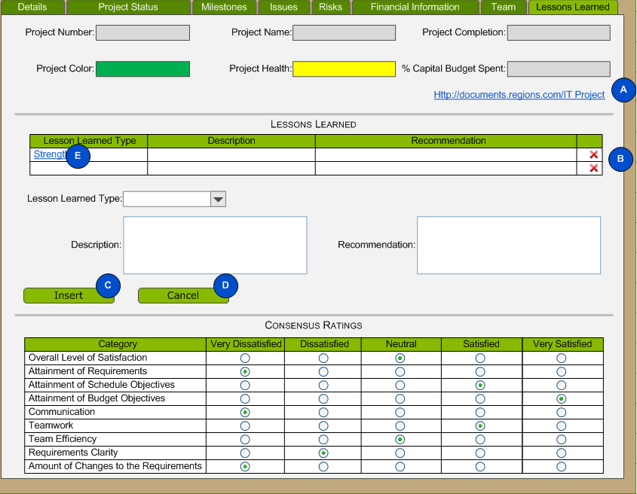

    - Workflow Models

      - Delete Lesson Learned

The following diagram illustrates Delete Lesson Learned workflow.

      - Insert Lesson Learned

The following diagram illustrates Insert Lesson Learned workflow.

      - Cancel Lesson Learned

The following diagram illustrates Cancel Lesson Learned workflow.

    - Error Messages

Message in workflow | Error Message
Delete Confirmation | “Are you sure you want to delete this Team Member?”
Missing Value | “Please [Select/Enter] a [Specific Field].”
Error | “The following error has occurred. [Error Number] – [Error Description]. Please contact your System Administrator.“
Cancel Confirmation | “Are you sure you want to cancel? All changes will be lost.”

    - Data Dictionary

The following table describes the attributes related to the Maintain Project Lessons Learned Process.

Attribute | Data Type | Format | Details | Max Length
Project Number | Calculated |  | - This is a view-only field.  - See 6.3.7 Format Project Number Business Rule.
Project Name  (Project.ProjectName) | String |  | - This is a view-only field. | 50
Project Completion | Calculated |  | - This is a view-only field.  - See 6.5.9 Calculate Project Completion
Project Rating | Calculated |  | - This is a view-only field.  - See 6.4.9 Calculate Project Rating Color.  - See 6.4.9 Calculate Project Rating Text.
Project Health  (ProjectHealth. ProjectHealth) | Integer |  | - This is a view-only field.
% Capital Budget Spent | Calculated |  | - This is a view-only field.  - See 6.5.9 Calculate % Capital Budget Spent.
Project Site Hyperlink  (Project.ProjectDirectory) | String |  | - This is a view-only field. | 255
Lesson Learned Type  (LessonLearnedType.LessonLearnedType) | String | Hyperlink | - This field is required.  - This field in the grid will contain a hyperlink that opens the selected record for editing. | 25
Description  (LessonLearned.Description) | String |  | - This field is required. | 255
Recommendation  (LessonLearned.Recommendation) | String |  | - This field is required. | 255
Lesson Learned Type Select List | SelectList
Category  (RatingCategory.RatingCategory) | String |  |  | 50
Very Dissatisfied  (ProjectRating.VeryDissatisfied) | Boolean |  | - This field is required.
Dissatisfied  (ProjectRating..Dissatisfied) | Boolean |  | - This field is required.
Neutral  (ProjectRating.Neutral) | Boolean |  | - This field is required.
Satisfied  (ProjectRating.Satisfied) | Boolean |  | - This field is required.
Very Satisfied  (ProjectRating.VerySatisfied) | Boolean |  | - This field is required.

    - Business Rules

Business Rule | Description
Sorting and Grouping | The Lessons Learned grid will group and sort by Lesson Learned Type and Description.

  - Manage Lookup Tables

    - Overview

The Manage Lookup Tables process launches the Administration page within the Venture solution. Venture administrative users will utilize this page to manage lookup table values. The data dictionary describes the information the user will maintain.

    - Activities that Triggers Process

The user initiates this process by clicking on the Administration link.

    - Process Results

The result of this process is that the solution has saved lookup table information to the SQL Database.

    - Actors Involved

The following list identifies the actors that interact with the Manage Lookup Tables screen:

- Administrator

    - Storyboard

The following diagram illustrates the Lookup Tables Page that the solution will utilize to support the Maintain Lookup Tables Process.

- If the user clicks the delete icon, the solution will delete the selected project Line of Business from the database. The Delete Lookup Value workflow below describes the transition.
- If the user clicks the Insert/Update button, the solution will insert or update the selected Line of Business record. The Insert Lookup Value workflow below describes the transition.
- If the user clicks the Cancel button, the solution will clear the Line of Business entry fields and change the text of the Insert/Update button to Insert. The Cancel Lookup Value workflow below describes the transition.
- If the user clicks the delete icon, the solution will delete the selected Department from the database. The Delete Lookup Value workflow below describes the transition.
- If the user clicks the Insert/Update button, the solution will insert or update the selected Department record. The Insert Lookup Value workflow below describes the transition.
- If the user clicks the Cancel button, the solution will clear the Department entry fields and change the text of the Insert/Update button to Insert. The Cancel Lookup Value workflow below describes the transition.
- If the user clicks the delete icon, the solution will delete the selected Resource from the database. The Delete Lookup Value workflow below describes the transition.
- If the user clicks the Insert/Update button, the solution will insert or update the selected Resource record. The Insert Lookup Value workflow below describes the transition.
- If the user clicks the Cancel button, the solution will clear the Resource entry fields and change the text of the Insert/Update button to Insert. The Cancel Lookup Value workflow below describes the transition.
- If the user clicks the delete icon, the solution will delete the selected Project Indicator from the database. The Delete Lookup Value workflow below describes the transition.
- If the user clicks the Insert/Update button, the solution will insert or update the selected Project Indicator record. The Insert Lookup Value workflow below describes the transition.
- If the user clicks the Cancel button, the solution will clear the Project Indicator entry fields and change the text of the Insert/Update button to Insert. The Cancel Lookup Value workflow below describes the transition.
- If the user clicks the delete icon, the solution will delete the selected Lesson Learned Type from the database. The Delete Lookup Value workflow below describes the transition.
- If the user clicks the Insert/Update button, the solution will insert or update the selected Lesson Learned Type record. The Insert Lookup Value workflow below describes the transition.
- If the user clicks the Cancel button, the solution will clear the Lesson Learned Type entry fields and change the text of the Insert/Update button to Insert. The Cancel Lookup Value workflow below describes the transition.

    - Workflow Models

      - Delete Lookup Value

The following diagram illustrates Delete Lookup Value workflow.

      - Insert Lookup Value

The following diagram illustrates Insert Lookup Value workflow.

      - Cancel Lookup Value

The following diagram illustrates Insert Lookup Value workflow.

    - Error Messages

Message in workflow | Error Message
Delete Confirmation | “Are you sure you want to delete this Team Member?”
Missing Value | “Please [Select/Enter] a [Specific Field].”
Error | “The following error has occurred. [Error Number] – [Error Description]. Please contact your System Administrator.“
Cancel Confirmation | “Are you sure you want to cancel? All changes will be lost.”

    - Data Dictionary

The following table describes the attributes related to the Manage Lookup Tables Process.

Attribute | Data Type | Format | Details | Max Length
Line of Business
Line of Business  (LOB.LOB) | String |  | - This field is required. | 50
Department
Department  (Department. Department) | String |  | - This field is required. | 100
Resources
Resource  (Resource.Resource) | String |  | - This field is required. | 50
Phone  (Resource.Phone) | String |  | - This field is required. | 20
Email  (Resource.Email) | String |  | - This field is required. | 75
User ID  (Resource.UserID) | String |  | - This field is required. | 25
Super User  (Resource.Super) | Boolean |  | - This field is required.
Update  (Resource.Update) | Boolean |  | - This field is required.
View  (Resource.View) | Boolean |  | - This field is required.
Project Indicator
Project Status  (Status.Status) | String |  | - This field is required. | 25
Project Indicator  (Indicator.ProjectIndicator) | String |  | - This field is required. | 50
Sort Number  (Indicator.SortNumber) | Integer |  | - This field is required.
Lesson Learned Type
Lesson Learned Type  (LessonLearnedType.LessonLearnedType) | String |  | - This field is required. | 25

- Data Requirements

The following sections present the data model for the Venture solution.

  - Project Tables

  - Issues and Milestones

  - Lessons Learned and Risk

- Quality Requirements

In order to ensure the required availability, accuracy, and security of the application, CTS must perform a number of quality assurance activities. The following table provides a list of Quality Assurance (QA) activities that CTS may perform during the engagement, along with a description of each activity.

QA Activity | Description | Will be performed
Black Box Testing | Black Box Testing is a testing technique whereby the tester does not know the internal workings of the item being tested. For example, in a Black Box Test the tester only knows the inputs and what the expected outcomes should be; not how the program arrives at those outputs. The tester does not examine the programming code and does not need any further knowledge of the program other than its requirements specifications. | Yes
Regression Testing | Regression Testing is the selective retesting of a software system that has been modified to ensure that any existing defects have been fixed, that no other previously working functions have failed as a result of the reparations, and that newly added features have not created problems with previous versions of the software. Regression Testing is initiated after a programmer has attempted to fix a recognized problem or has added source code to a program that may have inadvertently introduced errors. It is a quality control measure to ensure that the newly modified code still complies with its specified requirements and that unmodified code has not been affected by the maintenance activity. | Yes
Automated Functional Testing | Automated Functional Testing is the process of using a QA tool to automate many of the black box and regression testing activities of an engagement. While Automated Functional Testing requires more upfront effort, more thorough, repeatable testing can be performed with reduced effort once the automated tests have been developed. | No
White Box Testing | White Box Testing is a testing technique whereby explicit knowledge of the internal workings of the item being tested is used to select the test data. Unlike Black Box Testing, White Box Testing uses specific knowledge of programming code to examine outputs. The test is accurate only if the tester knows what the program is supposed to do. The tester can then see if the program diverges from its intended goal. White Box Testing does not account for errors caused by omission, and all visible code must also be readable. | Yes
Performance Testing | Performance Testing involves manual activities and the use of QA tools to measure the performance of the solution. The tester will execute each portion of the application and measure performance under various scenarios involving such factors as slow connections and large data volumes. | No
Security Testing | Security Testing is the testing of a software system to ensure security, authentication, and access to an application and its data. Testing also includes data encryption and decryption, password authentication rules, and data access privileges. Data recovery procedures are also tested. | Yes

- Report Requirements

  - General Requirements

The following table identifies general reporting requirements for the XYZ solution.

ID | Category | Requirement
 | Technology | CTS will develop all reports will in Microsoft SQL Server 2008 Reporting Services.
 | Technology | All reports will use the standard export features of Microsoft SQL Server Reporting Services.

  - View Flag Report

    - Overview

The Flag Report shows a list of all projects with the Add to Watchlist checked box checked grouped and sorted by Status, Project Level, Line of Business and then Department.

    - Actors Involved

The following list identifies the actors that interact with the View Detail Deposit report:

- User
- Administrator

    - Data Dictionary

Attribute | Data Type | Format | Details | Max Length
Report Date | DateTime
Project Level | String |  |  | 50
Project Name  (Project.ProjectName) | String |  |  | 50
Sponsors  (Resource.Resource) | String |  | - See Show Sponsors Business Rule | 50
Business Indicator  (Indicator.ProjectIndicator) | String |  | - See Current Month Business Indicator Business Rule | 50
Previous Month Business Indicator  (Indicator.ProjectIndicator) | String |  | - See Previous Month Business Indicator Business Rule | 50
Implement Date  (ProjectStandardMilestone.BaselineStart) (ProjectStandardMilestone.ActualStart) | DateTime |  | - See Implement Date Business Rule
Status Highlights  (ProjectStatus.ExecutiveSummary) | String |  | - See Status Highlights Business Rule | 3000
Approved Capital  (FinancialInformation.ApprovedCapital) | Money
Project Health  (ProjectHealth. ProjectHealth) | Integer |  | - See Project Health Business Rule
Previous Month Project Health  (ProjectHealth. ProjectHealth) | Integer |  | - See Previous Project Health Business Rule
Line of Business  (LOB.LOB) | String |  |  | 50
Department  (Department.Department) | String |  |  | 100
Page | Integer |  | - See Page Business Rule
Number Pages | Integer |  | - See Number Pages Business Rule

    - Business Rules

Business Rule | Description
Show Sponsors | The Sponsors field will contain the Executive Council Member and Project Sponsor from the Project Team. The Executive Council Member will come first followed by the Project Sponsor on a new line.
Previous Month Business Indicator | Previous Month Business Indicator is the last value of Business Indicator where the month in ProjectIndicator.IndicatorDate is less than or equal to the current month – 1.
Current Month Business Indicator | Current Month Business Indicator is the latest value of Indicator in Project Indicator where the month of IndicatorDate is equal to the current month.
Implement Date | The following table describes how the solution will utilize Implementation Standard Milestone to calculate Implement Date.
  Condition | Field to Use
  Actual Start Date is not Empty | Actual Start Date
  Actual Start Date is empty and Baseline Start Date is not empty | Baseline Start Date
Status Highlights | Status Highlights is equal to the most recent Executive Summary.
Project Health | Project Health is the latest value of Project Health in ProjectProjectHealth where the month of ProjectHealthDate is equal to the current month.
Previous Project Health | Previous Month Health is the last value of Project Health where the month in ProjectProjectHealth.ProjectHealthDate is less than or equal to the current month – 1.
Page | Standard Page Number of Reporting Services
Number Pages | Standard Number of Pages of Reporting Services
Status Sorting | The report will sort by status in the following order:  - Active  - Pending
TSC Total | The Flag Report will have a total for each Status – Project Level group.

  - View Weekly Status Report

    - Overview

The Weekly Status Report provide a snapshot of the current status of the project.

    - Actors Involved

The following list identifies the actors that interact with the View Weekly Status Report:

- User
- Administrator

    - Data Dictionary

Attribute | Data Type | Format | Details | Max Length
Project Name  (Project.ProjectName) | String |  |  | 50
Project Number  (Project.ProjectYear)  (Project.ProjectSeqNumber) | Integer |  | - See 6.3.7 Format Project Number Business Rule.
Project Manager  (Resource.Resource) | String |  | - See Project Manager Business Rule | 50
Project Sponsor  (Resource.Resource) | String |  | - See Project Sponsor Business Rule | 50
Line of Business  (LOB.LOB) | String |  |  | 50
Department  (Department.Department) | String |  |  | 100
As Of | DateTime |  | - Current Date
Current Project Health  (ProjectHealth. ProjectHealth) | Integer |  | - See 9.2.4 Project Health Business Rule
Executive Summary (ProjectStatus.ExecutiveSummary) | String |  | - 9.2.4 See Status Highlights Business Rule | 3000
% Capital Budget Spent | Calculated |  | - 6.4.9 See Calculate % Capital Budget Spent
Accomplishments  (ProjectStatus.Accomplishments) | String |  | - See Accomplishments Business Rule | 3000
Planned Activities  (ProjectStatus.PlannedActivities) | String |  | - See Planned Activities Business Rule | 3000
Milestones |  |  | - See Milestones Business Rule
Milestone  (StandardMilestone.StandardMilestone)  (ProjectMilestone.Milestone) | String |  |  | 50
Start  (ProjectStandardMilestone.BaselineStart)  (ProjectMilestone.BaselineStart)  (ProjectStandardMilestone.ActualStart)  (ProjectMilestone.ActualStart) | DateTime |  | - See Milestone Start Business Rile
Projected Finish  (ProjectStandardMilestone.RevisedFinished)  (ProjectMilestone.RevisedFinish) | DateTime
Actual Finish  (ProjectStandardMilestone.ActualFinished)  (ProjectMilestone.ActualFinish) | DateTime
Actual %  (ProjectStandardMilestone.PercentComplete)  (ProjectMilestone.PercentComplete) | Decimal
Risks |  |  | - See Risks Business Rule
ID  (Risk.RiskNumber) | Integer
Owner  (Resource.Resource) | String |  |  | 50
Risk  (Risk.Risk) | String |  |  | 255
Mitigation  (Risk.MitigationApproach) | String |  |  | 255
Status  (RiskStatus.RiskStatus) | String |  |  | 25
Target Date  (Risk.TargetDate) | DateTime
Issues |  |  | - See Issues Business Rule
ID  (Issue.IssueNumber) | Integer
Assigned To  (Resource.Resource) | String |  |  | 50
Description  (Issue.Issue) | String |  |  | 255
Status  (IssueStatus.IssueStatus) | String |  |  | 15
Due Date  (Issue.TargetDate) | DateTime
Action Items |  |  | - See Action Items Business Rule
ID  (Issue.IssueNumber) | Integer
Assigned To  (Resource.Resource) | String |  |  | 50
Description  (Issue.Issue) | String |  |  | 255
Next Action  (Issue.NextAction) | String |  |  | 255
Status  (IssueStatus.IssueStatus) | String |  |  | 15
Due Date  (Issue.TargetDate) | DateTime

    - Business Rules

Business Rule | Description
Project Manager | The Project Manager field will contain the Technical Project Manager from the Project Team.
Project Sponsor | The Project Sponsor field will contain the Project Sponsor from the Project Team.
Accomplishments | Accomplishments is equal to the most recent Accomplishment.
Planned Activities | Planned Activities is equal to the most recent Planned Activities.
Milestones | This section will show all Standard Milestones and all Project Specific Milestones with a Show in Status Report value equal to true.
Risks | This section will show all Risks with a Show in Status Report value equal to true.
Issues | This section will show all Project Tracking Items of type Issue with a Status of Open.
Action Items | This section will show all Project Tracking Items of type Action Item with a Status of Open.
Milestone Start | The following table describes how the solution will calculate the start date for the specific milestone.
  Condition | Field to Use
  Actual Start Date is not Empty | Actual Start Date
  Actual Start Date is empty and Baseline Start Date is not empty | Baseline Start Date
Milestone Sorting and Grouping | The Milestones grid will sort by Start in ascending order.
Action Item Sorting and Grouping | The Action Item Grid will sort by Due Date in descending order.
Issues Sorting and Grouping | The Issue Grid will sort by Due Date in descending order.
Risks Sorting and Grouping | The Risks Grid will sort by Target Date in descending order.
Filters | The solution will allow the user to specify the Project. CTS will implement the filter using the parameter capabilities of SQL Server Reporting Services.
No Items Found | If the Issues, Risks or Action Items table is empty, display *None.

  - View Lessons Learned Report

    - Overview

The Lessons Learned Report contains the Lessons Learned for the project.

    - Actors Involved

The following list identifies the actors that interact with the View Lessons Learned report:

- User
- Administrator

    - Data Dictionary

Attribute | Data Type | Format | Details | Max Length
Consensus Ratings
Category  (RatingCategory.RatingCategory) | String |  |  | 50
Very Dissatisfied  (ProjectRating.VeryDissatisfied) | Boolean
Dissatisfied  (ProjectRating..Dissatisfied) | Boolean
Neutral  (ProjectRating.Neutral) | Boolean
Satisfied  (ProjectRating.Satisfied) | Boolean
Very Satisfied  (ProjectRating.VerySatisfied) | Boolean
Lessons Learned
Type  (LessonLearnedType.LessonLearnedType) | String |  |  | 25
Description  (LessonLearned.Description) | String |  |  | 255
Recommendation  (LessonLearned.Recommendation) | String |  |  | 255

    - Business Rules

Business Rule | Description
Sorting and Grouping | The Lessons Learned grid will group and sort by Lesson Learned Type and Description.
Filters | The solution will allow the user to specify the Project. CTS will implement the filter using the parameter capabilities of SQL Server Reporting Services.

- Report Model Requirements

CTS will implement a Microsoft SQL Server Reporting Services report model to provide ABC Bank with the ability to generate their own reports. The table in section 10.1 describes the fields from the database that will be included in the report model. The following table describes the columns in the table in section 10.1.

Field | Description
Table | The table in the Venture database the model field comes from.
Field | The field in the Venture database the model field comes from.
Friendly Name | The field name users will see in Microsoft Report Builder.
Default Attribute | Fields in a report model with a Default attribute equal to true in a report model automatically get added to a report when the user clicks on an entity.
Hide in Model | Fields in a report model with a Hide attribute equal to try in a report model are not visible to users in Report Builder.

  - Report Model Details

Table | Field | Friendly Name | Default Attribute | Hide in Model
Department | Department | Department | X
Department | DepartmentID |  |  | X
FinancialInformation | ApprovedCap | Approved Cap Salary | X
FinancialInformation | ApprovedCapital | Approved Capital | X
FinancialInformation | ApprovedExpense | Approved Expense | X
FinancialInformation | BaselineCap | Baseline Cap Salary | X
FinancialInformation | BaselineCapital | Baseline Capital | X
FinancialInformation | BaselineExpense | Baseline Expense | X
FinancialInformation | CapitalSpent | Capital Spent | X
FinancialInformation | CapSpent | Capital Salary Spent | X
FinancialInformation | CostCenter | Cost Center
FinancialInformation | CumalativeNEIImpact | Cumalative NEI Impact | X
FinancialInformation | CumulativeNetIncome | Cumulative Net Income | X
FinancialInformation | ExpenseSpent | Expense Spent | X
FinancialInformation | FinancialInformationID |  |  | X
FinancialInformation | PendingCapital | Pending Capital | X
FinancialInformation | PendingExpense | Pending Expense | X
FinancialInformation | ProjectID |  |  | X
Impact | Impact | Risk Impact | X
Impact | ImpactID |  |  | X
Indicator | Deleted |  |  | X
Indicator | IndicatorID |  |  | X
Indicator | ProjectIndicator | Project Indicator | X | X
Indicator | SortNumber | Number to Sort Project Indicator
Issue | ActualDate | Issue Actual Date | X
Issue | DepartmentID |  |  | X
Issue | Issue | Issue | X
Issue | IssueID |  |  | X
Issue | IssueNumber | Issue ID | X
Issue | IssueStatusID |  |  | X
Issue | IssueTypeID |  |  | X
Issue | NextAction | Issue Next Action | X
Issue | ProjectIssueID |  |  | X
Issue | ProjectTeamID |  |  | X
Issue | Source | Issue Source | X
Issue | TargetDate | Issue Target Date | X
IssueStatus | IssueStatus | Issue Status | X
IssueStatus | IssueStatusID |  |  | X
IssueType | IssueType | Issue Type
IssueType | IssueTypeID |  |  | X
LessonLearned | Description | Lessons Learned Description | X
LessonLearned | LessonLearnedID |  |  | X
LessonLearned | LessonLearnedTypeID |  |  | X
LessonLearned | ProjectID |  |  | X
LessonLearned | Recommendation | Lessons Learned Recommendation | X
LessonLearnedType | LessonLearnedType | Lessons Learned Type | X
LessonLearnedType | LessonLearnedTypeID |  |  | X
LOB | Deleted |  |  | X
LOB | LOB | Line of Business | X
LOB | LOBID |  |  | X
Probability | Probability | Probability | X
Probability | ProbabilityID |  |  | X
Project | Benefits | Benefits
Project | BusinessIssue | Business Issue
Project | DepartmentID |  |  | X
Project | LOBID |  |  | X
Project | ProjectDirectory | Project Directory
Project | ProjectGoalID |  |  | X
Project | ProjectID |  |  | X
Project | ProjectLevelID |  |  | X
Project | ProjectName | Project Name | X
Project | ProjectYear & “ – “ & ProjectSeqNumber | Project Number | X
Project | Solution | Solution
Project | Watchlist | Add to Watchlist
ProjectGoal | ProjectGoal | Project Goal
ProjectGoal | ProjectGoalID |  |  | X
ProjectHealth | ProjectHealth | Project Health
ProjectHealth | ProjectHealthID |  |  | X
ProjectIndicator | IndicatorDate | Indicator Date
ProjectIndicator | IndicatorID |  |  | X
ProjectIndicator | ProjectID |  |  | X
ProjectIndicator | ProjectIndicatorID |  |  | X
ProjectLevel | ProjectLevel | Project Level
ProjectLevel | ProjectLevelID |  |  | X
ProjectMilestone | ActualFinish | Actual Finish | X
ProjectMilestone | ActualStart | Actual Start | X
ProjectMilestone | BaselineFinish | Baseline Finish | X
ProjectMilestone | BaselineStart | Baseline Start | X
ProjectMilestone | Milestone | Milestone | X
ProjectMilestone | PercentComplete | Percent Complete | X
ProjectMilestone | ProjectID |  |  | X
ProjectMilestone | ProjectMilestoneID |  |  | X
ProjectMilestone | RevisedFinish | Revised Finish | X
ProjectMilestone | RevisedStart | Revised Start | X
ProjectMilestone | ShowInReport | Show In Report | X
ProjectProjectHealth | ProjectHealthDate | Project Health Date |  | X
ProjectProjectHealth | ProjectHealthID |  |  | X
ProjectProjectHealth | ProjectID |  |  | X
ProjectProjectHealth | ProjectProjectHealthID |  |  | X
ProjectRating | Dissatisfied | Dissatisfied | X
ProjectRating | Neutral | Neutral | X
ProjectRating | ProjectID |  |  | X
ProjectRating | ProjectRatingID |  |  | X
ProjectRating | RatingCategoryID |  |  | X
ProjectRating | Satisfied | Satisfied | X
ProjectRating | VeryDissatisfied | Very Dissatisfied | X
ProjectRating | VerySatisfied | Very Satisfied | X
ProjectStandardMilestone | ActualFinish | Actual Finish | X
ProjectStandardMilestone | ActualStart | Actual Start | X
ProjectStandardMilestone | BaselineFinish | Baseline Finish | X
ProjectStandardMilestone | BaselineStart | Baseline Start | X
ProjectStandardMilestone | PercentComplete | Percent Complete | X
ProjectStandardMilestone | ProjectID |  |  | X
ProjectStandardMilestone | ProjectStandardMilestoneID |  |  | X
ProjectStandardMilestone | RevisedFinish | Revised Finish | X
ProjectStandardMilestone | RevisedStart | Revised Start | X
ProjectStandardMilestone | ShowInReport | Show In Report | X
ProjectStandardMilestone | StandardMilestoneID |  |  | X
ProjectStatus | Accomplishments | Accomplishments
ProjectStatus | ExecutiveSummary | Executive Summary
ProjectStatus | PlannedActivities | Planned Activities
ProjectStatus | ProjectID |  |  | X
ProjectStatus | ProjectStatusID |  |  | X
ProjectStatus | StatusDate |  |  | X
ProjectTeam | Deleted | Date Deleted From Team
ProjectTeam | ProjectID |  |  | X
ProjectTeam | ProjectTeamID |  |  | X
ProjectTeam | ResourceID |  |  | X
ProjectTeam | TeamRoleID |  |  | X
RatingCategory | RatingCategory | Rating Category | X
RatingCategory | RatingCategoryID |  |  | X
Resource | Deleted | Date Resource Deleted
Resource | Email | Email
Resource | Phone | Phone
Resource | Resource | Resource | X
Resource | ResourceID |  |  | X
Resource | Super | Super User
Resource | Update | Update Permission
Resource | UserID | User ID
Resource | View | View Permission
Risk | ImpactID |  |  | X
Risk | MitigationApproach | Mitigation Approach | X
Risk | Notes | Notes | X
Risk | ProbabilityID |  |  | X
Risk | ProjectID |  |  | X
Risk | ProjectRiskID |  |  | X
Risk | ProjectTeamID |  |  | X
Risk | Risk | Risk
Risk | RiskID |  |  | X
Risk | RiskNumber | Risk ID | X
Risk | RiskStatusID |  |  | X
Risk | ShowInStatus | Show In Status Report
Risk | TargetDate | Target Date | X
RiskStatus | RiskStatus | Risk Status | X
RiskStatus | RiskStatusID |  |  | X
StandardMilestone | StandardMilestone | Standard Milestone | X
StandardMilestone | StandardMilestoneID |  |  | X
Status | StatusID |  |  | X
Status | Status | Status | X
TeamRole | TeamRole | Team Role | X
TeamRole | TeamRoleID |  |  | X

- Data Conversion Requirements

The following table describes the Clarity fields required for conversion and the corresponding SHARK fields.

Clarity | Shark | Comments
Project ID | Project Number
Project Name | Project Name
Purpose | Business Issue
Scope | Solution
Project Approval Date | Actual Start of Approval Standard Milestone | Default to 100%
Implementation Start Target | Baseline Start of Implementation Standard Milestone
Implementation Start Actual | Actual Start of Implementation Standard Milestone
Implementation End | Baseline Finish of Implementation Standard Milestone
Implementation Finish Actual | Actual Finish of Implementation Standard Milestone
Implementation Finish Percent Complete | Percent Complete of Implementation Standard Milestone
Close End | Baseline Finish of Close Standard Milestone
Actual Close | Actual Finish of Close Standard Milestone
Revised Close | Revised Finish of Close Standard Milestone
Status Comment | Executive Summary | An Executive Summary record requires a date. We will use the data conversion is performed.
Cost Center | Cost Center
Current Original Cap Salary | Baseline Cap Salary
Cap Salaries Project Revised | Approved Cap Salary
Cap Salaries Project Actual | Cap Salary Spent
Approved Planned Original Total | Baseline Capital
Revised Planned Total | Approved Capital
Actual Total | Capital Spent
Line of Business | Line of Business | The Clarity data for this field has known data integrity issues.
Executive Council Member | Executive Council Member (Team List) | If individual is not in the database table, the data conversion process will add this individual with a blank phone number and email address.
Project Level | Project Level | The following table describes the mapping of Clarity to SHARK values.
  Clarity | Shark
  Level 1 | Non-TSC
  Level 2 | TSC
ITM Project Sponsor | Project Sponsor (Team List) | If individual is not in the database table, the data conversion process will add this individual with a blank phone number and email address.
Technology Services | Program Manager (Team List) | If individual is not in the database table, the data conversion process will add this individual with a blank phone number and email address.
Other1 | Technology Project Manager (Team List) | If individual is not in database table, the data conversion process will add this individual with a blank phone number and email address.
Project Manager | LOB Project Manager (Team List) | If individual is not in the database table, the data conversion process will add this individual with a blank phone number and email address.
IT Director | IT Director (Team List) | If individual is not in the database table, the data conversion process will add this individual with a blank phone number and email address.

CTS makes the following assumptions about the data conversion process:

- The data conversion process will only pull project details for projects with one of the following Status Codes:
  - Approved
  - Completed
- The data conversion process will pull Project Name and Project Number for all projects.
- The data conversion process will consider projects with a Percent Complete of 100% as Completed.
- ABC Bank requested a report to show data conversion errors. ABC Bank will be responsible for cleaning up the issues in Clarity. The team will rerun the data conversion process after ABC Bank fixes the errors. TBD1 – What fields are required on report?

- Performance Requirements

The total number of users of the solution is less than 100. The expected number of concurrent users should not exceed 100. The following table illustrates the concurrent users if ABC Bank Technology had a 5% yearly growth in the number of concurrent users.

Year | Projected Number of Concurrent Users | Calculation
2010 | 105 | 100 * 1.05 = 105
2011 | 111 | 105* 1.05 = 110.25
2012 | 116 | 110.25* 1.05 = 115.76

- Delivery Requirements

CTS will deliver the solution on CD ROM. The CD will include:

- Setup Programs
- Source Code
- System Delivery Document

CTS will be required to provide assistance when ABC Bank deploys the application to the test environment. ABC Bank will handle the installation in the production environment.

- Documentation Requirements

The following forms of documentation will be required:

- System Delivery Document

- Training Requirements

CTS will not provide training services related to this project.

- Client Requirements

Matt Wyatt will act as the engagement point of contact. He will be responsible for responding to requests for information and will provide support for information requests, equipment or software procurement, and engagement acceptance.

ABC Bank will make personnel resources available as required by project activities. CTS will estimate the time required for each resource.

- Formal Change Process

  - Change Initiated by Client

    - Client completes a Request for Change describing the desired modification.

    - CTS project team reviews the RFC for cost and schedule implications.

    - CTS project team provides the cost and schedule implications to the Client, who may approve or reject implementing the RFC.

  - Change Initiated by CTS

    - CTS project team completes a Request for Change describing the desired modification along with cost and schedule implications.

    - Client reviews the RFC and may approve or reject implementing the RFC.

- Screen Shots

- View Today

- Maintain Project Details

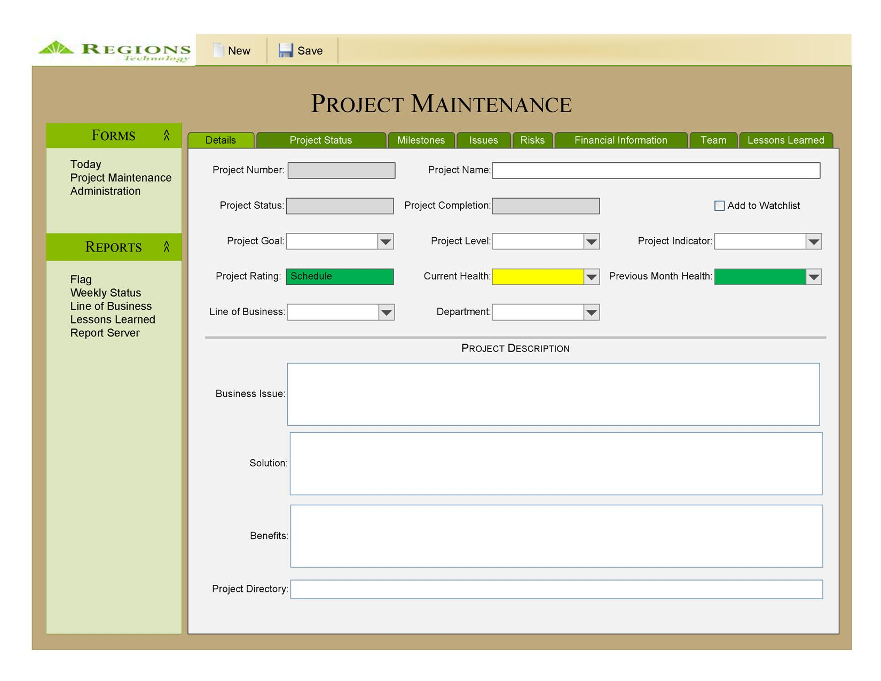
- Maintain Project Status

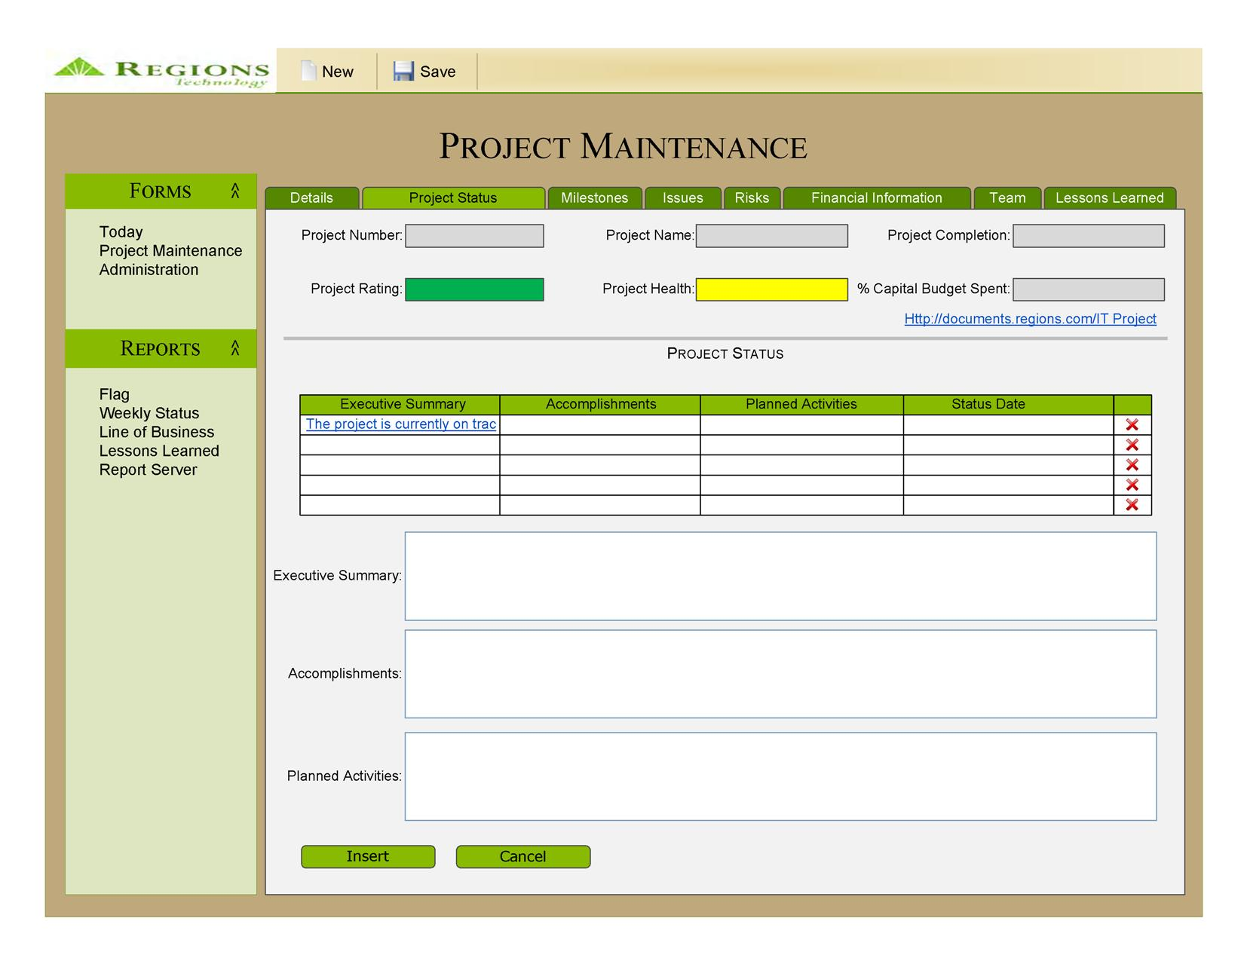
- Maintain Project Milestones

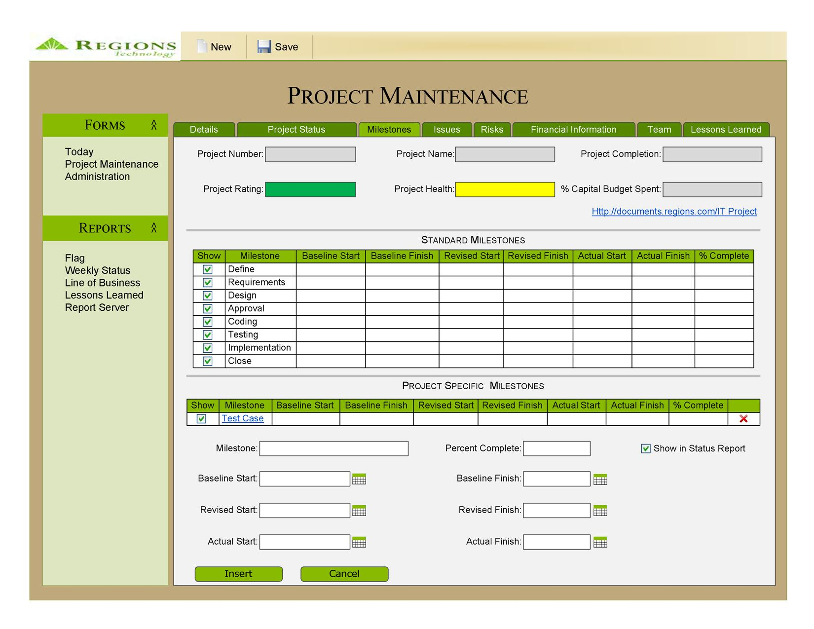
- Maintain Project Issues

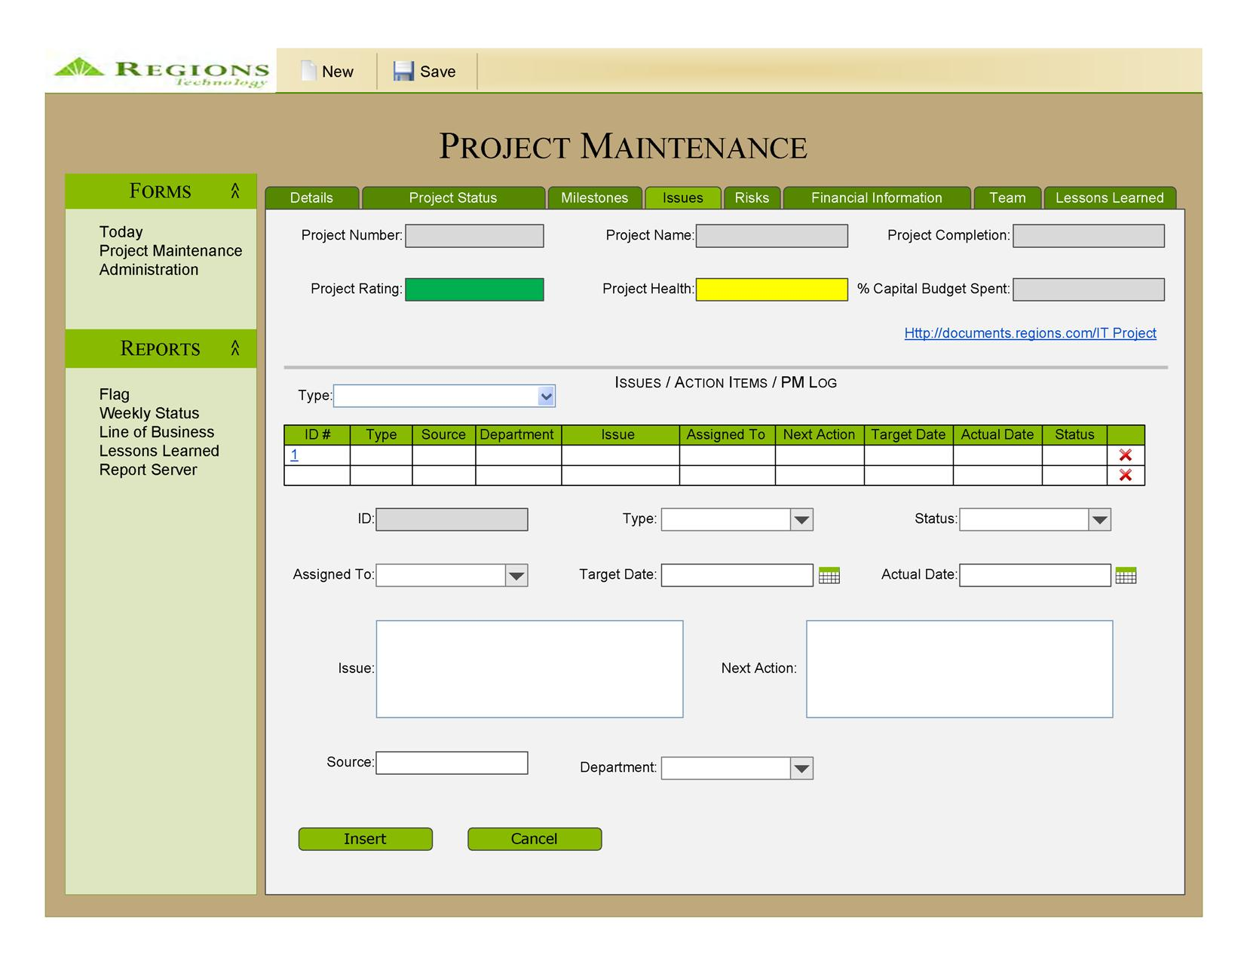
- Maintain Project Risks

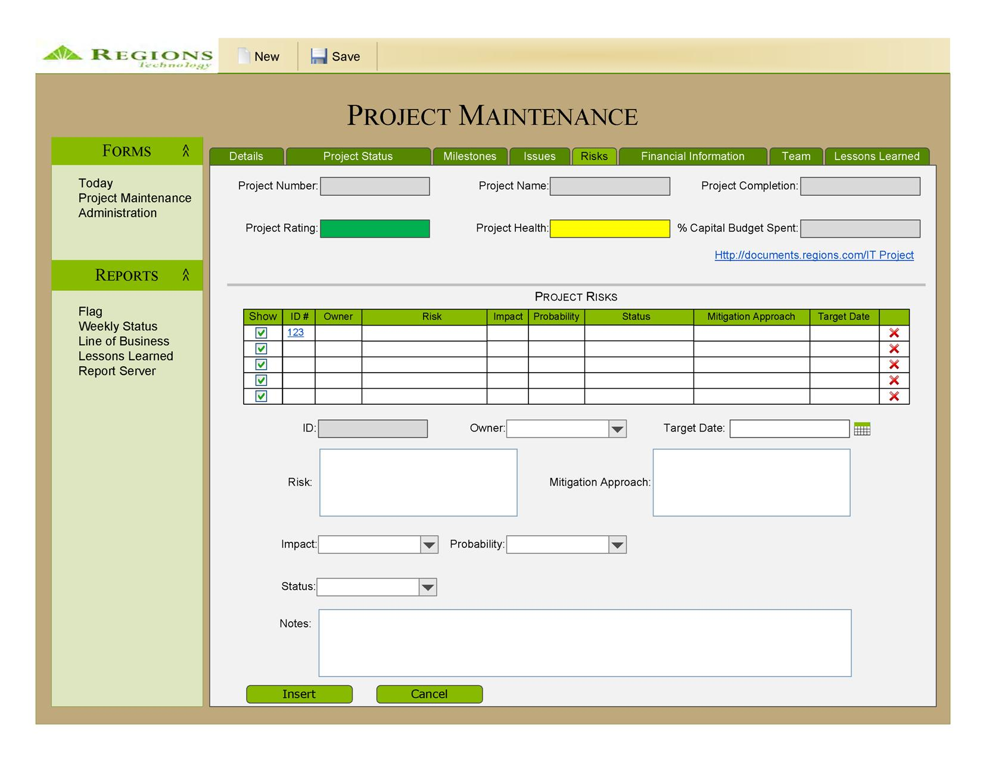
- Maintain Project Financial Information

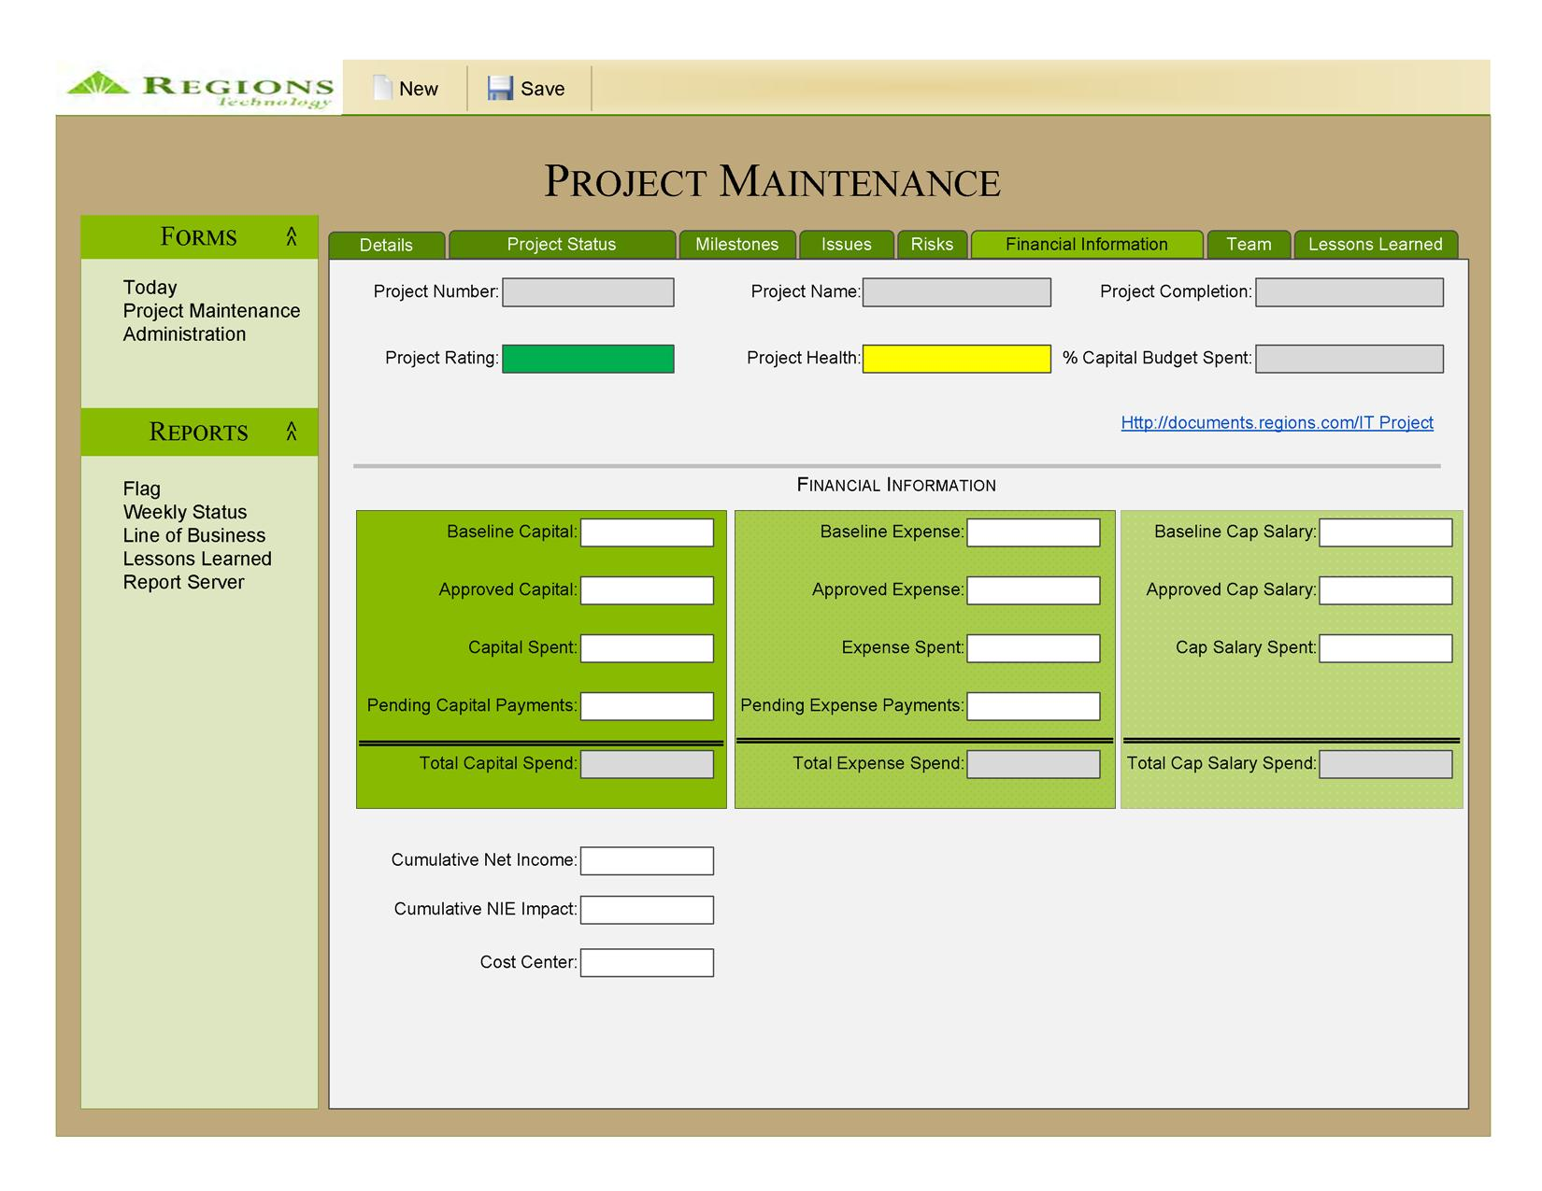
- Maintain Project Team

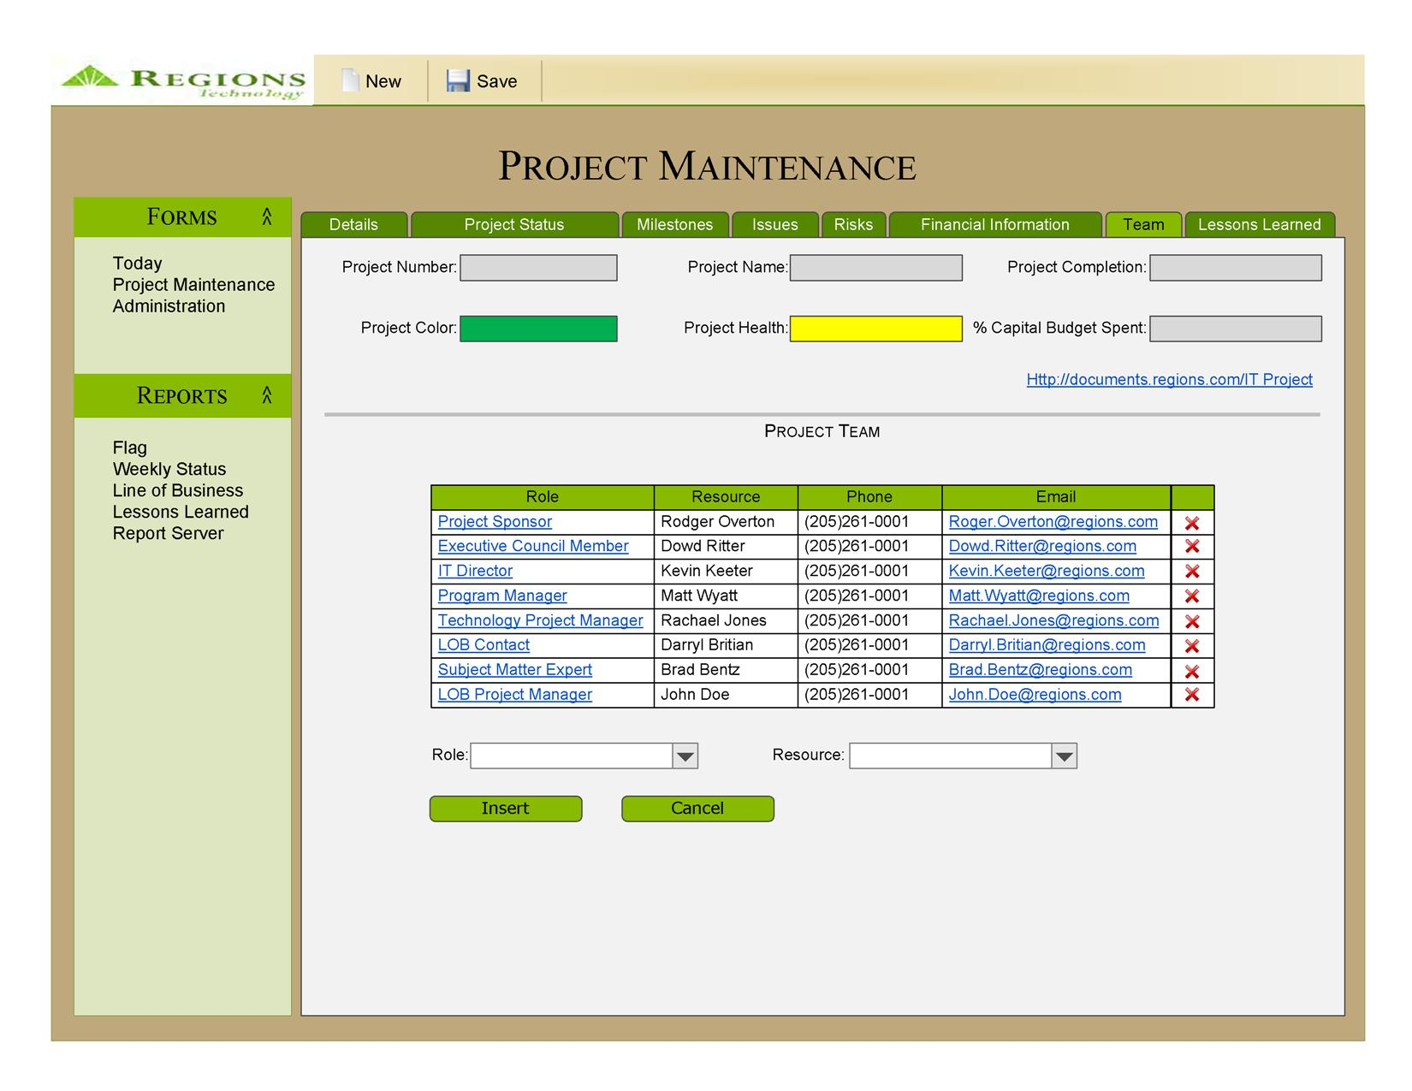
- Maintain Project Lessons Learned

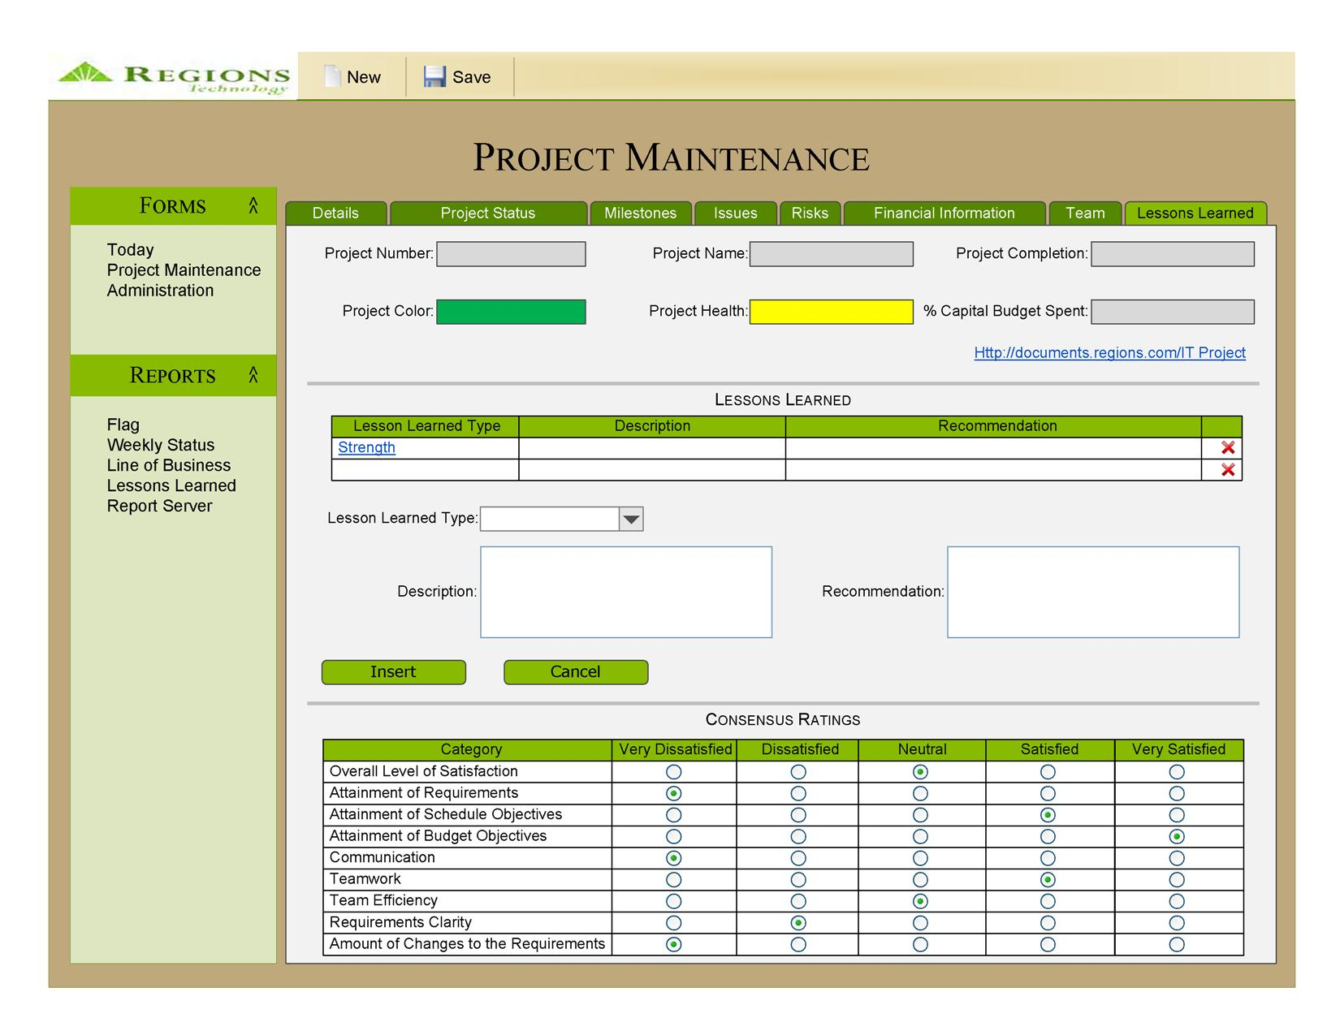
- Maintain Lookup Tables

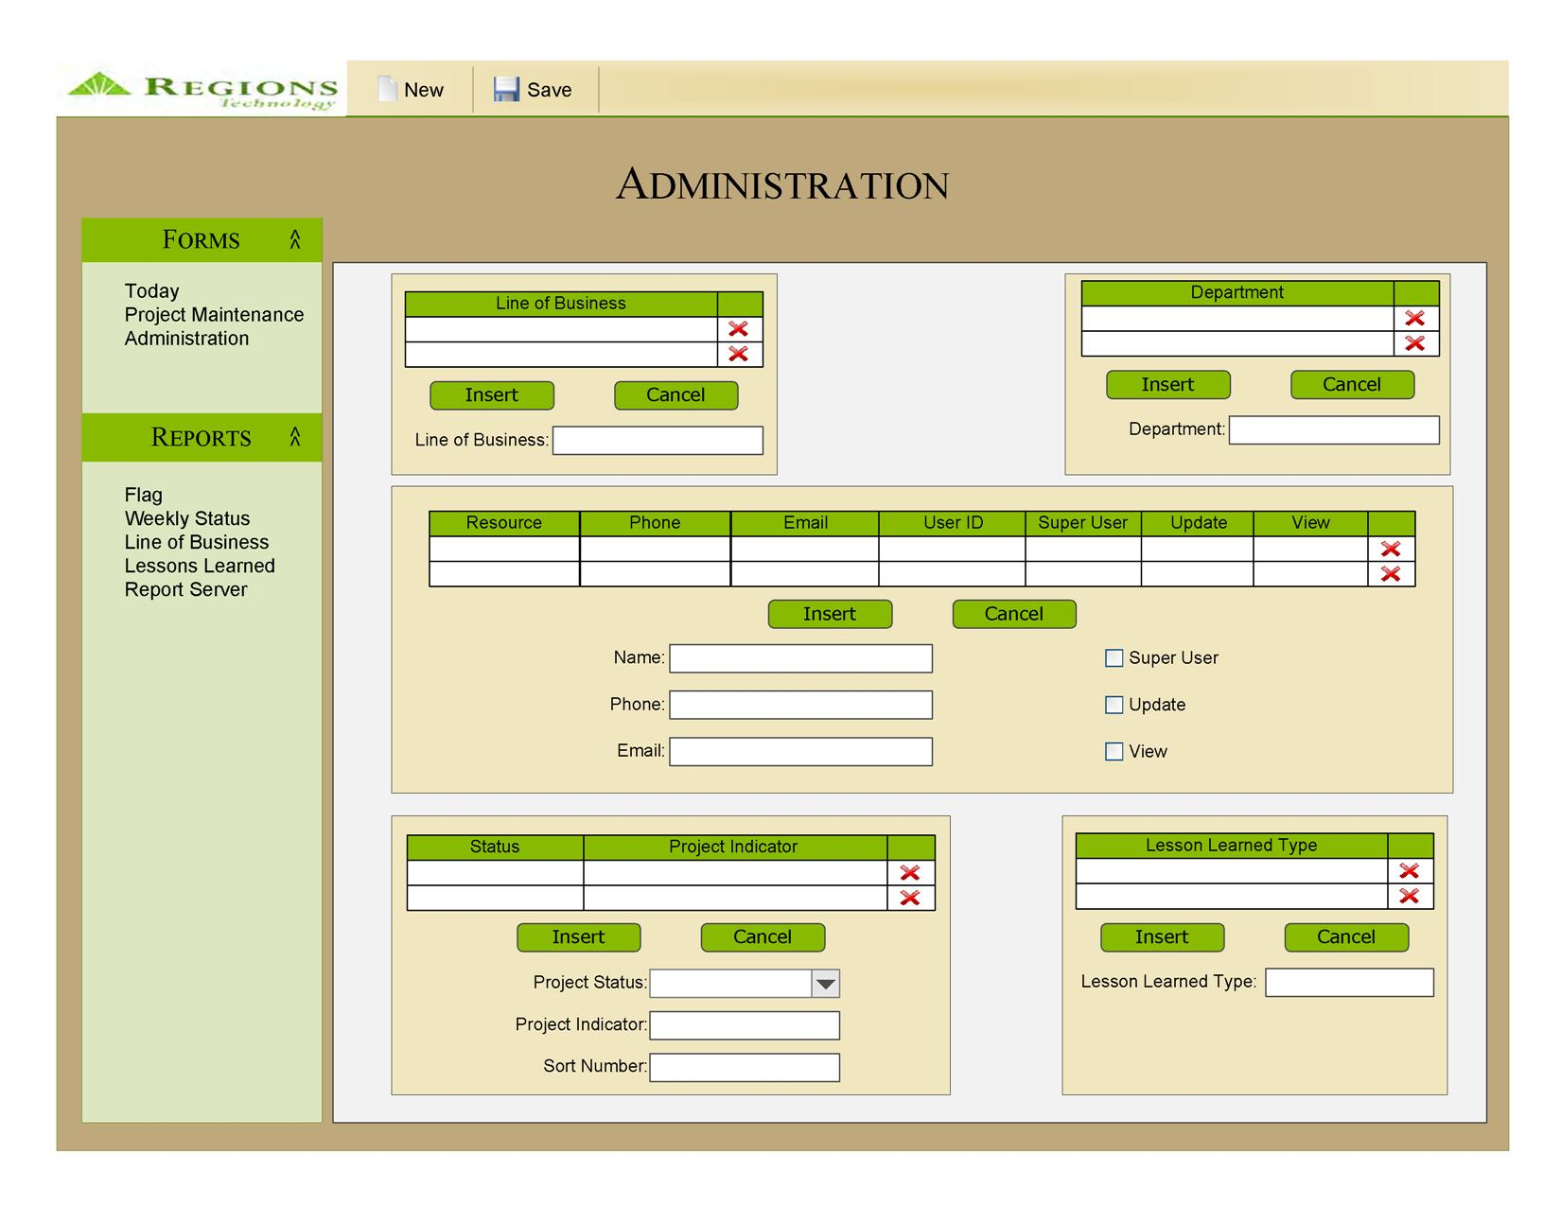

- Report Layouts

- View Flag Report


Project
Name
Sponsors
Business
Indicator
Previous
Month
Implement
Date
Status Highlights
Approved
Capital
Project
Health
Prev Mth
Project
Health
iTreasury
Release 7.5
Tim Laney
Arthur Scott
5/31/2010
The Test Environment set up in Nashville
has been delayed by an estimated 8 weeks
due to delayed techical meetings
$7,875,508
AFS Level 3
Release 8.3
Tim Laney
1/17/2010
The latest Executive Summary goes here.
$7,875,508
(Project
Name)
(Exec Councel
Member)
(Project
Sponsor)
1/17/2010
The latest Executive Summary goes here.
$7,875,508
(Project
Name)
(Exec Councel
Member)
(Project
Sponsor)
1/17/2010
The latest Executive Summary goes here.
$7,875,508
(Project
Name)
(Exec Councel
Member)
(Project
Sponsor)
1/17/2010
The latest Executive Summary goes here.
$7,875,508
(Project
Name)
(Exec Councel
Member)
(Project
Sponsor)
1/17/2010
The latest Executive Summary goes here.
$7,875,508
(Project
Name)
(Exec Councel
Member)
(Project
Sponsor)
1/17/2010
The latest Executive Summary goes here.
$7,875,508
(Project
Name)
(Exec Councel
Member)
(Project
Sponsor)
1/17/2010
The latest Executive Summary goes here.
$7,875,508
(Project
Name)
(Exec Councel
Member)
(Project
Sponsor)
1/17/2010
The latest Executive Summary goes here.
$7,875,508
(Project
Name)
(Exec Councel
Member)
(Project
Sponsor)
1/17/2010
The latest Executive Summary goes here.
$7,875,508
Total TSC Capital $:
$78,755,080

(Line of Business)
(Department)
Page 1 of 1
ABC Bank
Active TSC Projects
6/9/2009
Business Services
(Line of Business)
(Department)
- View Weekly Status Report

- View Lessons Learned Report

- Data Dictionary

Table | Column | Data Type | Max Length | Required
Department | Deleted | bit |  | X
Department | Department | varchar | 100 | X
Department | DepartmentID | int |  | X
FinancialInformation | ApprovedCap | money
FinancialInformation | ApprovedCapital | money
FinancialInformation | ApprovedExpense | money
FinancialInformation | BaselineCap | money
FinancialInformation | BaselineCapital | money
FinancialInformation | BaselineExpense | money
FinancialInformation | CapitalSpent | money
FinancialInformation | CapSpent | money
FinancialInformation | CostCenter | varchar | 25
FinancialInformation | CumalativeNEIImpact | money
FinancialInformation | CumulativeNetIncome | money
FinancialInformation | ExpenseSpent | money
FinancialInformation | FinancialInformationID | int |  | X
FinancialInformation | PendingCapital | money
FinancialInformation | PendingExpense | money
FinancialInformation | ProjectID | int |  | X
Impact | Impact | varchar | 25 | X
Impact | ImpactID | int |  | X
Indicator | Deleted | bit |  | X
Indicator | IndicatorID | int |  | X
Indicator | ProjectIndicator | varchar | 50 | X
Indicator | SortNumber | int |  | X
Issue | ActualDate | datetime
Issue | DepartmentID | int |  | X
Issue | Issue | varchar | 255
Issue | IssueID | int |  | X
Issue | IssueNumber | int
Issue | IssueStatusID | Int |  | X
Issue | IssueTypeID | int |  | X
Issue | NextAction | varchar | 255
Issue | ProjectIssueID | int |  | X
Issue | ProjectTeamID | int |  | X
Issue | Source | varchar | 25
Issue | TargetDate | datetime
IssueStatus | IssueStatus | varchar | 15 | X
IssueStatus | IssueStatusID | int |  | X
IssueType | IssueType | varchar | 15 | X
IssueType | IssueTypeID | int |  | X
LessonLearned | Description | varchar | 255 | X
LessonLearned | LessonLearnedID | int |  | X
LessonLearned | LessonLearnedTypeID | int
LessonLearned | ProjectID | int
LessonLearned | Recommendation | varchar | 255
LessonLearnedType | LessonLearnedType | varchar | 25 | X
LessonLearnedType | LessonLearnedTypeID | int |  | X
LOB | Deleted | bit |  | X
LOB | LOB | varchar | 50 | X
LOB | LOBID | int |  | X
Probability | Probability | varchar | 25
Probability | ProbabilityID | int |  | X
Project | Benefits | varchar | 3000
Project | BusinessIssue | varchar | 3000
Project | DepartmentID | int
Project | LOBID | int
Project | ProjectDirectory | varchar | 255
Project | ProjectGoalID | int
Project | ProjectID | int |  | X
Project | ProjectLevelID | int
Project | ProjectName | varchar | 50 | X
Project | ProjectSeqNumber | int |  | X
Project | ProjectYear | int |  | X
Project | Solution | varchar | 3000
Project | Watchlist | bit
ProjectGoal | ProjectGoal | varchar | 50 | X
ProjectGoal | ProjectGoalID | int |  | X
ProjectHealth | ProjectHealth | int |  | X
ProjectHealth | ProjectHealthID | int |  | X
ProjectIndicator | IndicatorDate | datetime |  | X
ProjectIndicator | IndicatorID | int |  | X
ProjectIndicator | ProjectID | int |  | X
ProjectIndicator | ProjectIndicatorID | int |  | X
ProjectLevel | ProjectLevel | varchar | 50 | X
ProjectLevel | ProjectLevelID | int |  | X
ProjectMilestone | ActualFinish | datetime
ProjectMilestone | ActualStart | datetime
ProjectMilestone | BaselineFinish | datetime
ProjectMilestone | BaselineStart | datetime
ProjectMilestone | Milestone | varchar | 50
ProjectMilestone | PercentComplete | decimal
ProjectMilestone | ProjectID | int
ProjectMilestone | ProjectMilestoneID | int |  | X
ProjectMilestone | RevisedFinish | datetime
ProjectMilestone | RevisedStart | datetime
ProjectMilestone | ShowInReport | Bit
ProjectProjectHealth | ProjectHealthDate | datetime |  | X
ProjectProjectHealth | ProjectHealthID | Int |  | X
ProjectProjectHealth | ProjectID | Int |  | X
ProjectProjectHealth | ProjectProjectHealthID | Int |  | X
ProjectRating | Dissatisfied | Bit |  | X
ProjectRating | Neutral | Bit |  | X
ProjectRating | ProjectID | Int |  | X
ProjectRating | ProjectRatingID | Int |  | X
ProjectRating | RatingCategoryID | int |  | X
ProjectRating | Satisfied | bit |  | X
ProjectRating | VeryDissatisfied | bit |  | X
ProjectRating | VerySatisfied | bit |  | X
ProjectStandardMilestone | ActualFinish | datetime
ProjectStandardMilestone | ActualStart | datetime
ProjectStandardMilestone | BaselineFinish | datetime
ProjectStandardMilestone | BaselineStart | datetime
ProjectStandardMilestone | PercentComplete | decimal
ProjectStandardMilestone | ProjectID | int
ProjectStandardMilestone | ProjectStandardMilestoneID | int |  | X
ProjectStandardMilestone | RevisedFinish | datetime
ProjectStandardMilestone | RevisedStart | datetime
ProjectStandardMilestone | ShowInReport | bit
ProjectStandardMilestone | StandardMilestoneID | int
ProjectStatus | Accomplishments | varchar | 3000 | X
ProjectStatus | ExecutiveSummary | varchar | 3000 | X
ProjectStatus | PlannedActivities | varchar | 3000 | X
ProjectStatus | ProjectID | int
ProjectStatus | ProjectStatusID | int |  | X
ProjectStatus | StatusDate | datetime |  | X
ProjectTeam | Deleted | bit |  | X
ProjectTeam | ProjectID | int
ProjectTeam | ProjectTeamID | int |  | X
ProjectTeam | ResourceID | int |  | X
ProjectTeam | TeamRoleID | int |  | X
RatingCategory | RatingCategory | varchar | 50
RatingCategory | RatingCategoryID | int |  | X
Resource | Deleted | bit |  | X
Resource | Email | varchar | 75 | X
Resource | Phone | varchar | 20 | X
Resource | Resource | varchar | 50 | X
Resource | ResourceID | int |  | X
Resource | Super | bit |  | X
Resource | Update | bit |  | X
Resource | UserID | varchar | 25 | X
Resource | View | bit |  | X
Risk | ImpactID | int |  | X
Risk | MitigationApproach | varchar | 255
Risk | Notes | varchar | 3000
Risk | ProbabilityID | int |  | X
Risk | ProjectID | int
Risk | ProjectRiskID | int |  | X
Risk | ProjectTeamID | int |  | X
Risk | Risk | varchar | 255
Risk | RiskID | int |  | X
Risk | RiskNumber | Int
Risk | RiskStatusID | int |  | X
Risk | ShowInStatus | bit |  | X
Risk | TargetDate | datetime |  | X
RiskStatus | RiskStatus | varchar | 25
RiskStatus | RiskStatusID | int |  | X
StandardMilestone | StandardMilestone | varchar | 50
StandardMilestone | StandardMilestoneID | int |  | X
Status | StatusID | int
Status | Status | varchar | 25
TeamRole | TeamRole | varchar | 50 | X
TeamRole | TeamRoleID | int |  | X

- Request for Change

Request for Change

 |  | Engagement: |  | Venture
 |  | Tracking Number: |  | XXXX
Date Entered: | 7/9/2009 | Priority: |  | Urgent | High | Medium | Low
Requested By: |  | Urgent – Must be implemented immediately before other engagement activities can continue.  High – Must be implemented in this version, but other engagement activities can continue as normal.  Medium – Must be implemented, but can wait until a later version.  Low – There is not a hard deadline around implementing this change.
Estimated Hours:
Total Cost:
Description:
Briefly describe the RFC.

Considering the complexity of many software engagements, project managers need to consider what constraints exist for an engagement. Such constraints can be determined by the schedule-resources-features triangle, also known as the Iron Triangle. In a given engagement, two legs of the triangle can be determined at the cost of accepting the third leg. An RFC affects at least one of the legs in the triangle. These changes are outlined below for this RFC.

Features (Requirements) Affected:
Detail the features and requirements that the RFC affects. Outline each requirement change in a discrete and consistent manner.
Schedule Impact:
Clearly articulate the schedule impact due to the RFC.
Cost Impact:
Make sure you include time for the following activities in the total cost:

- Development
- QA
- Project Management
- Update of documentation
- Estimation and planning for the RFC
- Acceptance Testing
- Deployment
- Training

If the RFC is fixed cost, do not show the estimated hours.
Comments:
Approved?: | Yes | No
Client Representative:
Signature:
Date:
CTS Representative:
Signature:
Date:

- Future Versions Enhancements List

This list identifies future enhancements that the team will address in successive versions of the engagement. The purpose of this list is to document these enhancements since the current version of the system will not address them.

Date | Enhancement | Suggested By | Expected Version  (if applicable)
7/10/2009 | Provide ability to generate an email to all Project Team Members. | David Birdsong | 2.0

